**Grant Program Requirements:  
Soil Health Practices Grant**

1. **Match**No match is required.
2. **Grant Work Plan**A work plan shall be developed in eLINK and must be approved before execution of the grant agreement. The work plan needs to specify the total budgeted amount for both Financial Assistance and, if applicable, Technical Assistance/Engineering. Technical Assistance/Engineering activities must include a description of anticipated outcomes or accomplishments. Prior to work plan approval, a District Financial Assistance Policy and Ranking/Batching form must be uploaded into eLINK.

It is required that grantees budget conservation practice grant funds into eLINK as they are obligated, with a signed and approved contract in place. **A new activity must be created for each contract**. Lumping of multiple contracts under a grant activity will not provide the level of detail needed to satisfy federal reporting requirements. Workplans will be unlocked after grant execution and remain unlocked throughout the grant agreement period. The addition of each contract will provide BWSR the means to assess the level of funding obligation (contracts in-place) for additional grant funding requests.

1. **Funding Distribution**

**Base Grant:** Each eligible and participating grantee will receive an initial base grant of $180,000, consisting of $150,000 for Financial Assistance (Federal RCPP Funds) and up to $30,000 for Technical Assistance/Engineering or Financial Assistance (Clean Water Funds).

**Requesting Additional Grants**: Grantees are eligible to request additional grants of $120,000 on a monthly basis. Additional grants will be processed by BWSR on the last workday of every month. Additional grants are available to those that have obligated (in-contract) 80% of prior federal RCPP funds and is compliant with program guidelines. The additional grants will consist of $100,000 for Financial Assistance (Federal RCPP Funds) and up to $20,000 for Technical Assistance/Engineering or Financial Assistance (Clean Water Funds). Requests are limited to one grant per grantee per month. Additional grant requests submitted from April-June may not be processed until after July 1st, in accordance with BWSR financial procedures around the new state fiscal year. There is no limit to the number of additional grants a grantee can receive. These additional grant periods will continue until all program funds have been disbursed.

**Payment Schedule:** Each executed grant will be distributed in one advanced payment (100%) to the grantee.

1. **Eligible Activities**Land management activities must be offered to eligible land occupiers on eligible lands for the implementation of soil health management systems and practices. All practices must be planned, designed, and implemented to Natural Resource Conservation Service (NRCS) standards.

Participating Individuals or entities must meet compliance checks for program eligibility under 7 CFR part 12 and part 1400, subpart F; compliance activities under the National Environmental Policy Act (NEPA), National Historic Preservation Act (NHPA), and Endangered Species Act (ESA) will be eligible for this program.

**Land Uses**

This program is limited to the following NRCS designated land uses: Crop, Forest, Range, Pasture, Farmstead, Other Rural Land, and Associated Agricultural Land.

**Resource Concerns**

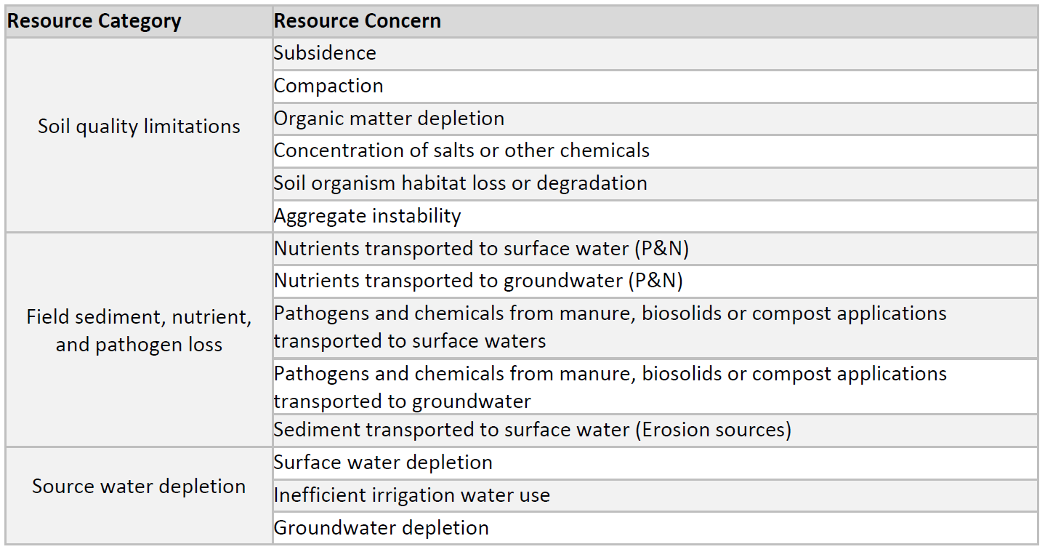Eligible practices must address, at minimum, one of the following resource concerns:

**Eligible Practices**

NRCS practice standards must be followed for the assessment, design, and certification of all practices listed in this section. If funding for direct, necessary, and approved supporting/facilitating practices falls within an eligible practice’s maximum payment rate, then all such practices must adhere to NRCS specifications and standards.

* Alley Cropping
* Conservation Cover
* Contour Buffer Strips
* Cover Crop
* Critical Area Planting
* Field Border
* Filter Strip
* Forest Farming
* Forest Stand Improvement
* Pasture and Hay Planting
* Prescribed Grazing
* Residue and Tillage Management (no till/strip till)
* Riparian Forest Buffer
* Silvopasture
* Tree/Shrub Establishment
* Windbreak/Shelterbelt Establishment and Renovation

**Staff Expenses**

Staff expenses are limited to Technical Assistance and Engineering and must fully support activities on eligible land, with eligible land occupiers, for eligible project activities. Staff expenses may not exceed $30,000 for Base Grants and $20,000 for each additional grant. **Technical Assistance and Engineering expenses must be tracked to individual contracts.**

**Ineligible Activities**

Funds may only be used for activities specified in the eligible practices list. Ineligible activities include, but are not limited to, project development, administration/coordination, and equipment purchases.

1. **Project Batching & Ranking**

It is a requirement of the Soil Health Practices Grant for the grantee to complete batching periods prior to contracting with land occupiers.

Batching periods may occur as frequently as once per month.

Ranking criteria must be developed and used to review every proposed project. At a minimum the following categories must be included:

* Proposed practice addresses an eligible program resource concern.
* Historically underserved producer: Determined through a self-certification form.
* First time practice implementor: Priority to those having limited experience with the proposed practice.
* Drinking water supply management areas (DWSMA).
* Sensitive ground water susceptibility regions outside of a DWSMA.
* High priority regions (Comprehensive Watershed Management Plan or other State Approved Plan)

In addition to the minimum requirements, grantees are encouraged to add other local priorities when developing their ranking criteria. Batching and Ranking criteria will be reviewed by NRCS to ensure criteria does not contain any discriminatory items.

1. **Farm Bill Payment Eligibility**

To ensure that both the land occupier and land are eligible for a Farm Bill payment an eligibility review must be conducted by SWCD staff.

Upon the obligation and approval of every practice contract, grantees must submit required documentation into SharePoint to allow NRCS to assist with payment eligibility determinations. NRCS will be completing random spot checks on SWCD eligibility reviews.

Within 30 days of disbursing funds to a land occupier, but after practice certification, the grantee must obtain a Producer Farm Data Report and Subsidiary print with Business report. The grantee needs to confirm that the land remains under the control of the contracted land occupier and that both the land occupier and the land have maintained eligibility for Farm Bill payments.

1. **Native Vegetation**Projects that involve vegetation restoration or establishment must use native vegetation and seed and plant sources consistent with BWSR’s Native Vegetation Establishment and Enhancement Guidelines, with the exceptions listed below. Use of plant species on the Minnesota [Noxious Weed List](https://www.mda.state.mn.us/plants-insects/minnesota-noxious-weed-list) is prohibited for all projects. Non-native species used for projects must not pose a risk to native plant communities. The maximum distance for sources of herbaceous species seed and plants is 200 miles; and for tree and shrubs seed and plants the distance is 300 miles.

**Exceptions**

* Non-native, non-invasive perennial crops, hay crops or forage crops may be used:
* As part of a drinking water protection strategy in a vulnerable or highly vulnerable DWSMA as designated by the Department of Health or in a Township Well Testing high-priority area as determined by the Department of Agriculture;
* In buffers, borders, grass waterways or other areas likely to be exposed to pesticides or part of agricultural production;
* For soil stabilization, erosion prevention and carbon sequestration in an agricultural production setting;
* On fields that will be hayed, grazed or harvested.
* For the exemptions above, if the project area is under 20 acres in size, the exception may be approved by local conservation staff. If the project area is 20 acres or larger, or for any exceptions not listed here, grantees must request approval from the BWSR Grant Manager.
* Cover crops used to improve soil health and/or water quality are allowed without a maximum acreage limit.
* Temporary cover is allowed without a maximum acreage limit when needed to stabilize project sites prior to the construction of structural conservation practices.
* Cultivars of native species may be used in urban stormwater plantings if they accomplish similar or greater ecological functions, help achieve aesthetic goals and do not pose an invasive or other environmental risk.

1. **Allowable and Unallowable Costs**Allowable costs are costs solely incurred though project activities that are directly related to and necessary for producing the project outcomes described in the work plan. Grantee is required to account for the staff time charged to BWSR grants in order to track the expenditure of grant funds and match to ensure the use of the funds is consistent with applicable State and BWSR requirements.

Unallowable costs include but are not limited to:

* Bad debts, monetary settlements and judgements, late payment fees, and investment management fees
* Donations, fundraising, sponsorships, and acknowledgements
* Entertainment, gifts, prizes, and decorations
* Alcohol
* Interest on loans not authorized under state statute
* Loans of BWSR grant funds
* Lobbying, lobbyists, and political contributions
* Merit awards and bonuses

1. **Sub-agreements**Funds may be distributed to partner(s) through the use of sub-agreements. Activities identified in the sub-agreement must fit within the scope of the agreement between BWSR and the recipient and include requirements for fund distribution, implementation, and reporting.

1. **Technical Quality Assurance**  
   Practices and projects must meet the following requirements to ensure long-term public benefit:
   1. **Technical Assistance Providers.** Ensure that identified technical assistance provider(s) have the appropriate Job Approval Authority, technical expertise, skills, and training to their assigned role(s). Technical Approval Authority is not an approved credential for this grant.
   2. **Standards.** Ensure the use of appropriate NRCS practice standards for the identification of resource concerns, designs, and installations.
   3. **Certification.** Certify that the project was installed according to applicable NRCS plans, specifications, and standards.
   4. **Operation and Maintenance.** Ensure an appropriate NRCS operation and maintenance plan is implemented that identifies necessary activities and timing.
   5. **Periodic Project Inspection.** Conduct periodic project inspections to confirm the operation and maintenance plan is being followed and the project has not been altered or removed (M.S. §103C.501, Subd. 7).

NRCS will conduct quality assurance spot checks on a minimum of 5% of all **completed** practices. These spot checks will occur after a payment has been made to the contracted individual or entity.

BWSR may contract with a third party to conduct quality assurance spot checks on up to 5-10% of all **designed** practices to ensure eligible activities were planned and follow NRCS practice requirements.

1. **Project and Practice Assurances**A written agreement is required to ensure program requirements are met when installing projects and practices or providing financial assistance to a land occupier. Project and Practice Assurances must include technical and financial obligations and requirements for the installation, operation, and maintenance of the practice or project, including a plan for failures or noncompliance.
2. **Providing Financial Assistance to Land Occupiers  
   ​**All BWSR funds used by a recipient to provide financial assistance to a landowner or land occupier requires adequate project assurances.

**District Financial Assistance Policy**

A local SWCD financial assistance policy must be referenced in the work plan and attached within eLINK. Financial Assistance Polices should describe local program information such as payment rates, contract terms, inspection schedules, and payment schedules.

Grantees may provide financial assistance to land occupiers for eligible activities up to the maximum program payment rates. Maximum program payment rates will be listed on the Soil Health Practices SharePoint site. Periodically the maximum payment rates may be reviewed upon a written grantee request. Such requests must include quantitative justifications for any requested increase to a payment rate.

If local financial assistance policies exceed program payment rates, non-federal funding sources can be used to cover the additional cost.

Flat rates or percentage of installation cost contracts may be used. However, program reporting must follow the structure and/or units outlined within the maximum program payment rates listed on SharePoint (exp. cover crops can be paid under single or multiple species rates and should be based on per/acre calculations). Percentage of installation cost must not exceed the maximum payment rates. Contracted payment rates and compensation provided to land occupiers, must be justifiable. Justification shall be based on clear and rational assessment of the services rendered, resources utilized, or value received. No payment should exceed the actual or reasonably estimated costs directly associated with the project or activity to prevent overpayment.

Prepayments for contracts are not allowed. Payments to the contracted land occupier can only occur after practices have been properly certified as complete based on NRCS standards. Partial contract payments will be allowed to account for contracts that contain multiple practices or that span multiple years.

**Project Application and Agreements**  
Work completed prior to the signing of the agreement is not eligible.

**Contracts**

Conservation practice or financial assistance contracts between grant recipients and landowners are required when funds are used to provide financial assistance to install practices. When used, these contracts must, at a minimum: provide financial assistance information and expectations; identify the responsibility for operation and maintenance, including maintenance or control of the contributing watershed; include a technical and financial plan for failures; allow for inspections by the grantee of the practice; be in effect for a period corresponding to the NRCS expected life of the project; and may be required to include replacement provisions and pro-rated pollution effectiveness replacement.

Due to federal requirements, the following statements must be added to practice contracts:

• “This contract is contingent on maintaining eligibility for federal farm bill payments.” This will protect the grantee and BWSR in the instance a landowners eligibility changes during the contracted period.

• “The land occupier acknowledges they have received a copy of the historically underserved producer self-certification form.”

• “Allow the contracting SWCD, NRCS, the Board of Water and Soil Resources, or their authorized representative, access to and the right to examine all records, books, papers, or documents related to this contract” This statement will allow for a third-party technical spot-check.

Contract numbers must follow the provided unique identification format:

County Code – Grant Number (1, 2, etc.) – Contract Number

Example: 14-1-1 (Clay SWCD – Base Grant – Contract 1)

Contract lengths cannot exceed December 31st, 2028.

**File Documentation**

Completed project files must contain, but are not limited to, the following completed documents:

* Certification of Identity/Authorization to Release Information to a Third Party Form
* Producer Farm Data Report
* Subsidiary Print with Business Report
* Completed Batching & Ranking Form (If applicable, include the Historically Underserved Self-Certification Form)
* Plan Map and As-Built
* Soils Map and map unit description
* Practice Design
  + Implementation Requirement (IR) Form, identifying resource concern(s)
  + Additional design requirements designated in practice standard
  + Operation and Maintenance Plans
  + Applicable Supporting Practice IR Forms and Designs
* CPA 52 – Environmental Evaluation, identifying resource concerns.
* CPA 6 – Conservation Notes
* CPA 48 - Cultural Resource Form (If applicable)
* Practice Contract
* Payment Voucher
* Supporting Documentation:
  + Quantities, Materials, Seed Tags, etc.
  + Applicable Invoices
  + Photos of implemented practices not required but strongly encouraged.

**Conservation Practice Contract Noncompliance**Failure to complete, maintain, or repair a conservation practice or unauthorized alteration is considered non-compliance with an executed conservation practice agreement. If the organization discovers noncompliance, they must take action to resolve and notify BWSR.

1. **Grant Management and Reporting**Grantee is required to report on the outcomes, activities, and accomplishments.

Grant reporting is a means to illustrate achievements and progress made towards program goals and to ensure accountability and transparency in the use of State funds. In general, reports are to contain updates on activities and expenditures that occurred since the previous report.

All land occupier data will be reported via a restricted access, grantee specific, SharePoint folder at the time of SWCD farm bill payment eligibility review and at time of financial assistance payment to the producer. It is the grantees responsibility to inform BWSR if an employee should no longer have access to SharePoint.

BWSR will use eLINK to report on grant progress, including expenditures, practice details, and mapping of practices.

Minnesota Statute §103B.3369, Subdivision 9 allows BWSR to consider additional performance-based criteria for grant programs and the Office of Grants Management’s Policy on Grant Closeout Evaluation (08-13) requires BWSR to consider a grant applicant’s past performance when awarding grants. BWSR may consider withholding grant payments if the grantee is not in compliance with all Board reporting requirements.