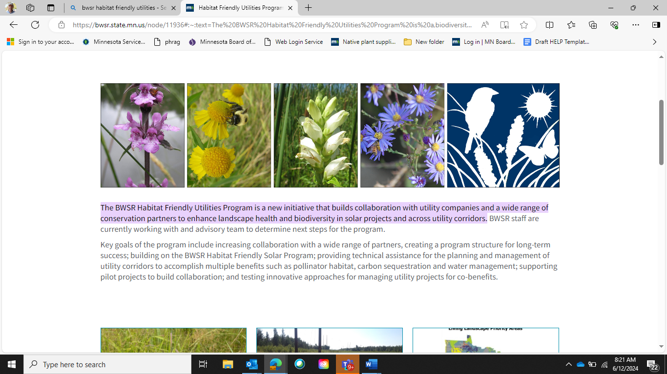

**Habitat Friendly Utilities Project Stories**

**City of Newport Utility Corridor**

**September 18, 2024**

**Location:** City of Newport

**Project Partners:** City of Newport, South Washington Watershed District, BWSR, Xcel Energy

**Project Co-Benefits:** Pollinator habitat, songbird habitat, plant diversity, water management, decreased long-term management costs

**Introduction**

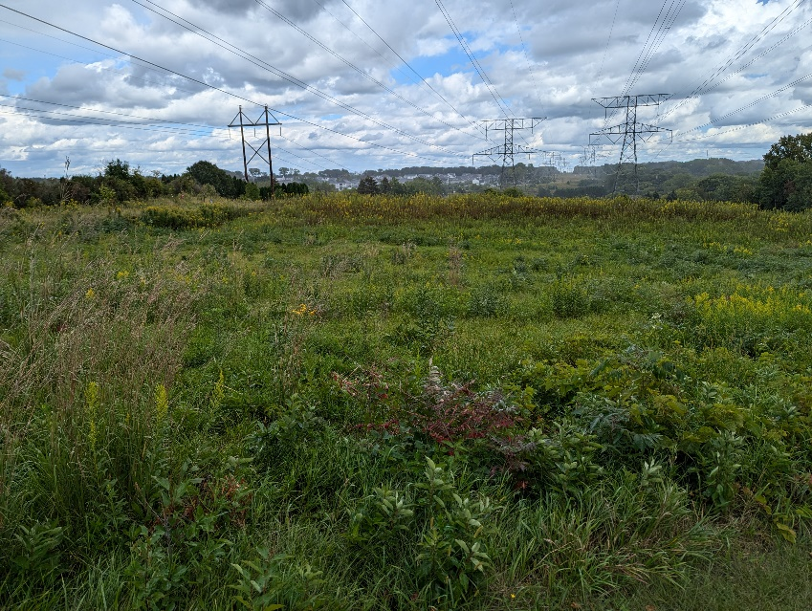The South Washington Watershed District (SWWD) works with its partner cities to help identify and develop plans, connect partners and help secure funding for the restoration and enhancement of natural areas within city open spaces. These activities help to support the SWWD mission of enhancing open spaces to provide habitat, build soil health, create resilient natural communities and protect water quality all intended to support overall watershed health. The Bailey School Forest Park is a 60 acre dedicated park located along the steep bluffs above the Mississippi River Valley. The park is comprised a mix of Oak Forest, Oak Savanna and Prairie extending over steep bluffs and deep ravines. It is also recognized as a School Forest by the Minnesota DNR, for years providing outdoor learning opportunities for students from the South Washington Schools. Bailey School Forest Park planning has focused on two distinct natural community types, oak woodland/forest and open grasslands/savanna both within and adjacent to existing electrical utility line corridors. This collaborative project with funding provided by BWSR is a partnership between these three public entities working to improve landscape resilience and partnering between public and private land managers.

**Project Establishment and Management**

The first phase of work will focus on around 20 acres of openings within the park largely dominated by grasslands both within and outside of a large transmission line corridor. The grasslands within the transmission line corridor have been maintained to limit the growth of woody plant material to facilitate the safe operation of overhead powerlines. Under utility lines, woody vegetation is viewed as a potential hazard to operations, so the partners are committed to restoring the grassland habitats with minimal trees and shrubs while and substantially increasing the diversity of deep rooted native grasses and flowering herbaceous species. Through the habitat Friendly Utility Program, the Minnesota Board of Water and Soil Resources (BWSR) will help to meet the operations and safety needs of the utility corridor while also working to enhance the habitat quality of the site located immediately above the Mississippi River. Work began in 2024 with a full mowing to suppress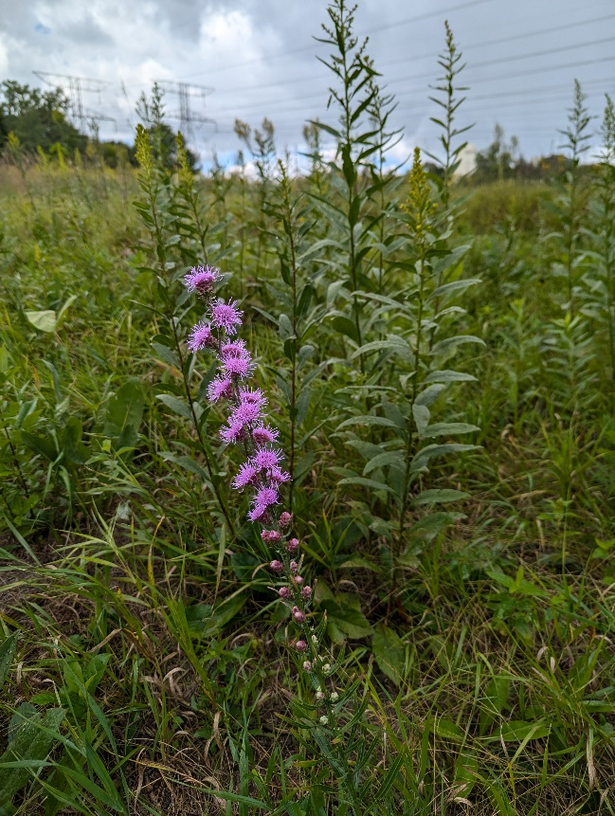 woody vegetation. Over the next three years, a combination herbicide application, mowing, prescribed fire and targeted over seeding will reestablish a highly diverse grassland. After this initial restoration and establishment period, city staff will be able to continue managing the site.

**Key Project Lessons**

The project will test innovative approaches for creating a high-quality grassland habitat where woody trees and shrubs are kept to a minimum through periodic regular maintenance by city staff while meeting the safety and operational needs of the utility corridor. SWWD and BWSR are working with a contractor to assess different approaches to woody vegetation and cool season grass control by assessing timing differences combined with mowing, prescribed fire and chemical type. This information will expand the knowledge base for professionals regionwide working on similar utility projects as the data becomes available. BWSR will make findings available on their What’s Working Program page.

**For more Information:**

Tony Randazzo at South Washington Watershed District at [tony.randazzo@woodburymn.gov](mailto:tony.randazzo@woodburymn.gov)