**Lakeshore Moist Soils Statewide Seed Mix Guidance**

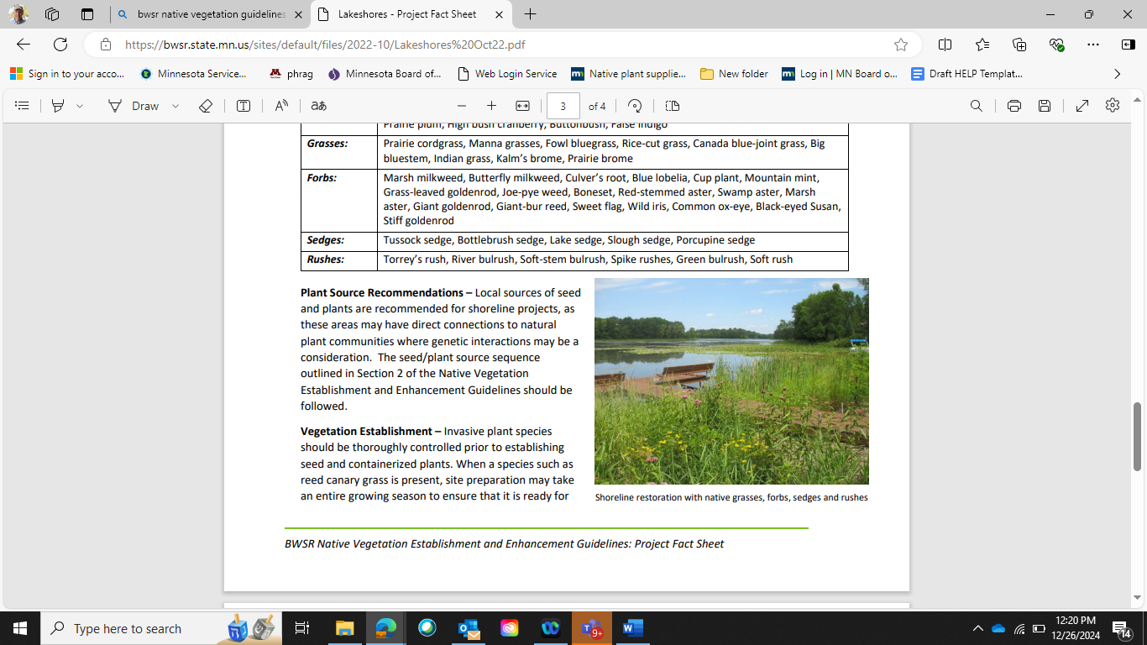 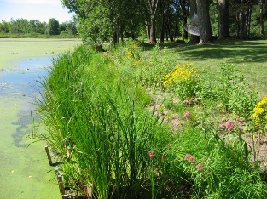 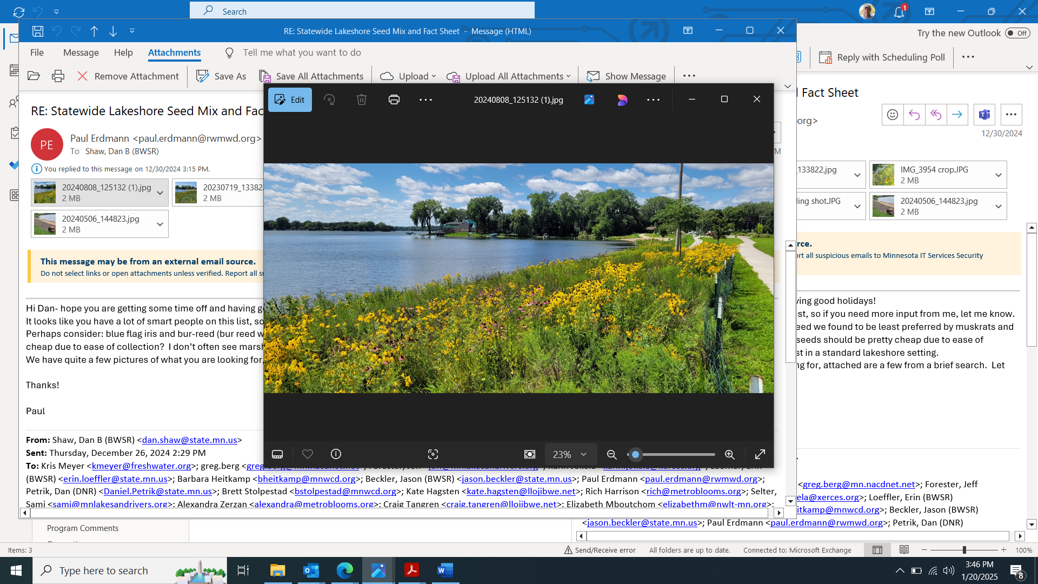

Updated: 2024

This mix has been designed for areas along lakeshores with full to partial sun, protected from waves or flowing water, and soil saturation within a foot of the surface during a majority of the growing season. The mix is well suited for developed lakeshores where lawn or non-native perennial grasses are being converted to native vegetation.

Partners also include collaboration among Non-profits, Seed vendors, SWCD, Tribal Governments, Consultants, County and Cities. (See partner list on [website](https://bwsr.state.mn.us/seed-mixes))

|  |  |  |  |  |  |  |
| --- | --- | --- | --- | --- | --- | --- |
|  | **34-264** | **Lakeshore Moist Soils Statewide Mix** |  |  |  |  |
| **Code** | **Common Name** | **Scientific Name** | **PLS lb/ac** | **% by PLS lb/ac** | **Seeds/ft2** | **% by Seeds/ft2** |
| calcan | bluejoint | *Calamagrostis canadensis* | 0.04 | 0.20% | 4.11 | 2.55% |
| elycan | nodding wild rye | *Elymus canadensis* | 1.05 | 5.16% | 2.01 | 1.24% |
| elyvir | Virginia wild rye | *Elymus virginicus* | 0.32 | 1.57% | 0.49 | 0.31% |
| glygra | tall manna grass | *Glyceria grandis* | 0.08 | 0.39% | 2.06 | 1.28% |
| glystr | fowl manna grass | *Glyceria striata* | 0.09 | 0.44% | 2.98 | 1.85% |
| panvir | switchgrass | *Panicum virgatum* | 1.36 | 6.68% | 6.99 | 4.34% |
| poapal | fowl bluegrass | *Poa palustris* | 0.13 | 0.64% | 6.21 | 3.85% |
| spapec | prairie cordgrass | *Spartina pectinata* | 0.21 | 1.03% | 0.51 | 0.32% |
|  |  | **Grasses Subtotal** | **3.28** | **16.12%** | **25.36** | **15.74%** |
| carhys | porcupine sedge | *Carex hystericina* | 0.14 | 0.69% | 1.54 | 0.96% |
| carsco | pointed broom sedge | *Carex scoparia* | 0.1 | 0.49% | 3.09 | 1.92% |
| carstr | tussock sedge | *Carex stricta* | 0.01 | 0.05% | 0.19 | 0.12% |
| carvul | fox sedge | *Carex vulpinoidea* | 0.22 | 1.08% | 8.08 | 5.02% |
| junnod | knotted rush | *Juncus nodosus* | 0.01 | 0.05% | 6.80 | 4.22% |
| sciatr | dark green bulrush | *Scirpus atrovirens* | 0.12 | 0.59% | 20.28 | 12.59% |
| scicyp | Woolgrass | *Scirpus cyperinus* | 0.05 | 0.25% | 31.22 | 19.38% |
|  |  | **Sedges & Rushes Subtotal** | **0.65** | **3.19%** | **71.20** | **44.20%** |
| agafoe | blue giant hyssop | *Agastache foeniculum* | 0.06 | 0.29% | 1.98 | 1.23% |
| anecan | Canada anemone | *Anemone canadensis* | 0.03 | 0.15% | 0.09 | 0.05% |
| ascinc | marsh milkweed | *Asclepias incarnata* | 0.14 | 0.69% | 0.25 | 0.15% |
| chegla | white turtlehead | *Chelone glabra* | 0.01 | 0.05% | 0.34 | 0.21% |
| eupper | common boneset | *Eupatorium perfoliatum* | 0.02 | 0.10% | 1.18 | 0.73% |
| eutgra | grass-leaved goldenrod | *Euthamia graminifolia* | 0.01 | 0.05% | 1.29 | 0.80% |
| eutmac | spotted Joe pye weed | *Eutrochium maculatum* | 0.03 | 0.15% | 1.05 | 0.65% |
| helaut | autumn sneezeweed | *Helenium autumnale* | 0.13 | 0.64% | 6.21 | 3.85% |
| iriver | northern blue flag | *Iris versicolor* | 0.1 | 0.49% | 0.05 | 0.03% |
| lobsip | Blue lobelia | *Lobelia siphilitica* | 0.03 | 0.15% | 5.51 | 3.42% |
| mimrin | blue monkey flower | *Mimulus ringens* | 0.02 | 0.10% | 16.90 | 10.49% |
| phyvir | obedient plant | *Physostegia virginiana* | 0.05 | 0.25% | 0.20 | 0.13% |
| pycvir | Virginia mountain mint | *Pycnanthemum virginianum* | 0.04 | 0.20% | 3.23 | 2.01% |
| rudhir | black-eyed susan | *Rudbeckia hirta* | 0.21 | 1.03% | 7.10 | 4.41% |
| scrlan | Lance-leaved Figwort | *Scrophularia lanceolata* | 0.03 | 0.15% | 2.04 | 1.27% |
| symlan | eastern panicled aster | *Symphyotrichum lanceolatum* | 0.03 | 0.15% | 1.72 | 1.07% |
| sympun | red-stemmed aster | *Symphyotrichum puniceum* | 0.03 | 0.15% | 0.88 | 0.55% |
| thadas | tall meadow-rue | *Thalictrum dasycarpum* | 0.07 | 0.34% | 0.19 | 0.12% |
| verhas | blue vervain | *Verbena hastata* | 0.09 | 0.44% | 3.07 | 1.91% |
| verfas | bunched ironweed | *Vernonia fasciculata* | 0.11 | 0.54% | 0.97 | 0.60% |
| vervir | Culver's root | *Veronicastrum virginicum* | 0.01 | 0.05% | 2.94 | 1.82% |
| zizaur | golden alexanders | *Zizia aurea* | 0.17 | 0.84% | 0.69 | 0.43% |
|  |  | **Forbs Subtotal** | **1.42** | **6.98%** | **57.85** | **35.91%** |
| avesat | Oats | *Avena sativa* | 15 | 73.71% | 6.68 | 4.15% |
|  |  | **Cover Crop Subtotal** | **15.00** | **73.71%** | **6.68** | **4.15%** |
|  |  | **Total** | **20.35** | **100.00%** | **161.09** | **100.00%** |

**Lakeshore Moist Soils Statewide Seed Mix Guidance**

**Seed mix name:** Lakeshore Moist Soils Statewide 34-264

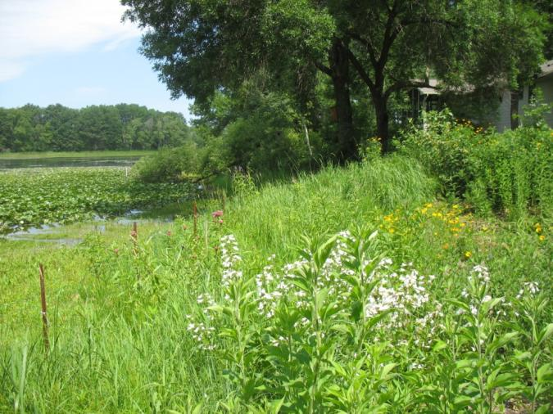

**Geographic area:** Statewide

**Year of development:** 2024

**Year/s of update:** NA

**Status** (Standard or Pilot mix): Standard

**Primary and Secondary Functions:**

*Primary* – Wildlife habitat, erosion prevention, restoration of lakeshore plant communities, and water management

*Secondary* – Carbon Sequestration, emission reductions, pollinator habitat, songbird habitat

**Similar State Mixes:** Wet Meadow Northeast 34-371, Wet Meadow South and West 34-372

**Compatible NRCS Practice Standards:** None

**Compatible Minnesota CRP Practices:** None

**Seed Sources:** The DNR website lists native seed vendors in Minnesota by region that can provide native plant seed at the following link: [Native plant suppliers, landscapers, and restoration consultants for Minnesota | Minnesota DNR](https://www.dnr.state.mn.us/gardens/nativeplants/suppliers.html)

**Suitable Site Conditions:** Areas along lakeshores with full to partial sun, protected from waves or flowing water, and soil saturation within a foot of the surface during a majority of the growing season. The mix is well suited for developed lakeshores where lawn or non-native perennial grasses are being converted to native vegetation. As soils become drier further upslope (typically one foot in elevation above the ordinary water level) separate seed mixes for upland prairies or woodlands should be selected based on site conditions. On sloping sites, the mix may be used in a narrow band near the water’s edge before transitioning to an upland mix. Most lakeshores are restored with a combination of seed and containerized plants. This seed mix has been developed as a companion to DNR planting templates for containerized plants. [Planting Trees and Shrubs on Your Shoreline](https://files.dnr.state.mn.us/waters/watermgmt_section/shoreland/shoreline-trees-shrubs.pdf), [Planting Perennials on Your Shoreline](https://files.dnr.state.mn.us/waters/watermgmt_section/shoreland/shoreline-herbaceous.pdf)

**How to Modify for Site Conditions and Goals:** Site conditions such as sunlight, soils, hydrology and existing vegetation along with functional goals for the project such as erosion prevention, carbon sequestration, pollinator habitat, and benefits to bird species can all have an influence on species selection and the modification of seed mixes. Although this mix provides guidelines for establishing herbaceous perennials, by seed, it is strongly recommended to complement near-shore seedings with both containerized plants and woody vegetation using bare root trees/shrubs, or live stakes. This is primarily due to the added importance of establishing these sensitive sites quickly, and to provide as much protection from erosion as possible. In sites that are particularly erosion prone, consider higher concentrations of more aggressive species such as shrub willows, dogwoods, bluejoint grass, or common rush. Additionally, higher densities an annual cover crop, such as oats, or winter wheat can help hold soil in place more effectively. It is also common that seed substitutions are used for lakeshore seed mixes when other species are not available. It is recommended to work with native seed vendors as they can recommend seed substitutions when species are not available. This mix has been designed to complement Minnesota DNR lakeshore plantings templates. Some smaller residential lakeshores may be established with mulched (such as shredded hardwoods) containerized plant without seed if the plants are spaced close enough to ensure establishment (around 1.5 feet apart). If a site is successfully seeded containerized plants can be used at a wider spacing, or species that don’t successfully establish from seed can be planted. Seed will not germinate through heavy mulch. In addition to the DNR planting templates native seed vendors can provide species recommendations. The Minnesota DNR’s “[Restore Your Shore](https://www.dnr.state.mn.us/rys/index.html)” website is also a valuable tool for species selection.

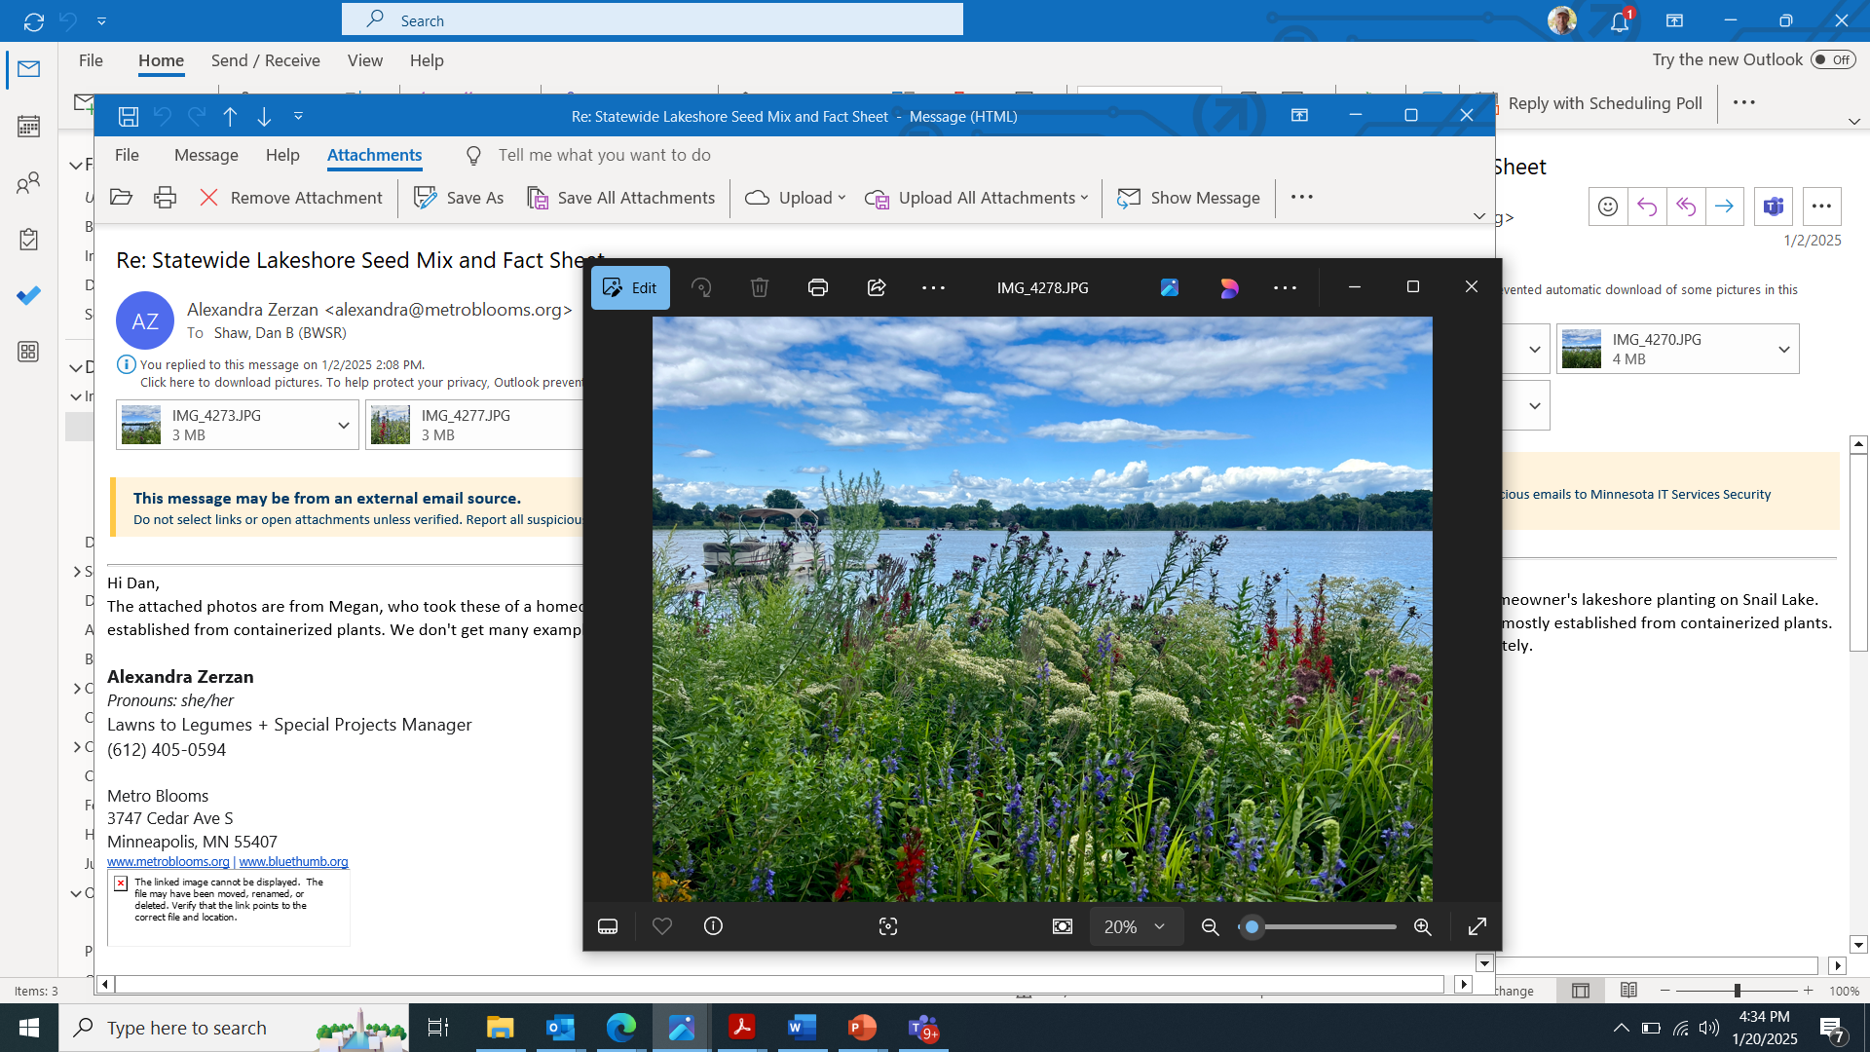

Site established with only containerized plants

**Site Preparation:** Primary goals for site preparation tend to focus on controlling weed species and providing ideal growing conditions for seed or plants to be installed. In these near-shore situations, efforts should be made to minimize soil disturbances. Any native plants already established should be maintained. Additionally, dead or fallen trees should be kept in place to maintain habitat for fish, ducks, birds, turtles, and other critters. Site preparation methods vary depending on past uses of the site and the weed species that are present. The protection of soil health and native seedbanks, preventing soil erosion, and managing weed establishment are all considerations during the site preparation process. If a lakeshore project will have exposed soils and has either wave impacts or steep slopes, then plastic-free erosion control fabric, biologs, wattles, and/or wave absorption techniques may be needed to prevent erosion from reaching the lake. Conservation professionals should be consulted in these situations.

In most cases, non-herbicide methods are preferred over herbicide methods for weed removal to protect aquatic organisms and soil microfauna, but herbicides may be the most efficient method of controlling most invasive perennial species. It is not effective to seed into live grass. Although tilling or sod removal is typically needed to ensure adequate seed to soil contact, these methods should be used with caution in near-shore situations and should be paired with a plastic-free erosion control fabric. One way to minimize soil disturbances is through dormant or snow seeding, as described below.

All weeds still need to be controlled before seeding even if they are sparse or they will provide ongoing competition for native species. Smothering turf grasses with cardboard, black plastic, tarps, or similar materials can be used to kill turf grasses but typically need to be used for a full growing season for effective control. These materials will need to be removed prior to seeding. The [Lawns to Legumes Program](https://bwsr.state.mn.us/l2l) provides resources about turf removal options (and is a potential funding source for Minnesota residents). For more naturalized areas with invasive weeds smothering methods can also be used for removal, or scattered weeds can be dug using a spade or mattock. Herbicides that are used along lakeshores must be labeled for use near water, including glyphosate products (such as Rodeo® or AquaNeat®) or triclopyr amine products (such as Garlon® 3A or Element® 3A). For aggressive weed species such as purple loosestrife and giant reed grass, a combination of mowing, herbicide application, prescribed burning, and tilling may be needed. The [Minnesota Wetland Restoration Guide](https://bwsr.state.mn.us/mn-wetland-restoration-guide) provides detailed management recommendations for a wide range of species. It is highly recommended to **have conservation professionals assess naturalized areas** before controlling vegetation to ensure that native plants or other important resources will not be impacted. Following weed removal efforts native plants may germinate from seed that were suppressed by the weeds, subsequently increasing the diversity of the planting.

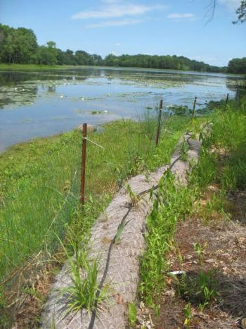

Site where biologs have been installed for additional stabilization and protection from waves

**Seeding Dates:** Lakeshore seed mixes are most often installed in the fall after October 15th as a dormant seeding as most sedges, rushes and forbs need a winter to break their seed dormancy and start growing. It is also common to wait until shortly before snowfall to prevent the loss of seed from wind, birds and rodents. Snow seeding is conducted during early or late winter when there is less than four inches of snow, and on sunny days when seed can increase in temperature and move to the soil surface. This technique has been successful for a wide variety of species types. Refer to the Minnesota Wetland Restoration Guide for more information about snow seeding. Lakeshore seed can also be installed in the spring once soil temperatures reach 50 degrees Fahrenheit until June 30th but only a portion of the seed mix will germinate that first year as some species will require a winter to break dormancy. If a lakeshore project will have flowing or fluctuating water levels it may be better to seed later in the spring after water levels stabilize.

**Seedbed preparation:** Methods that are used to prepare a seedbed can vary depending on the type of seeding to be conducted. Broadcast seeding is most often conducted for lakeshore projects. Prior to seeding native plant any weeds must be thoroughly controlled so they won’t compete with native plant seedlings. Broadcast seeding can be conducted onto bare soils, or into standing dead vegetation as long as there are gaps of bare soil. Soils that are hard packed at the surface should be loosened about an inch deep to improve seed to soil contact and to ensure that seed is not washed away. Deep tilling should not be conducted right before seeding as tiny seeds of lakeshore species may get buried too deep as the soil settles. Additionally, tilling will make the site more susceptible to erosion. If deeper tilling is conducted the site should be rolled to create a firm surface. Watering or rainfall can also help the soil settle.

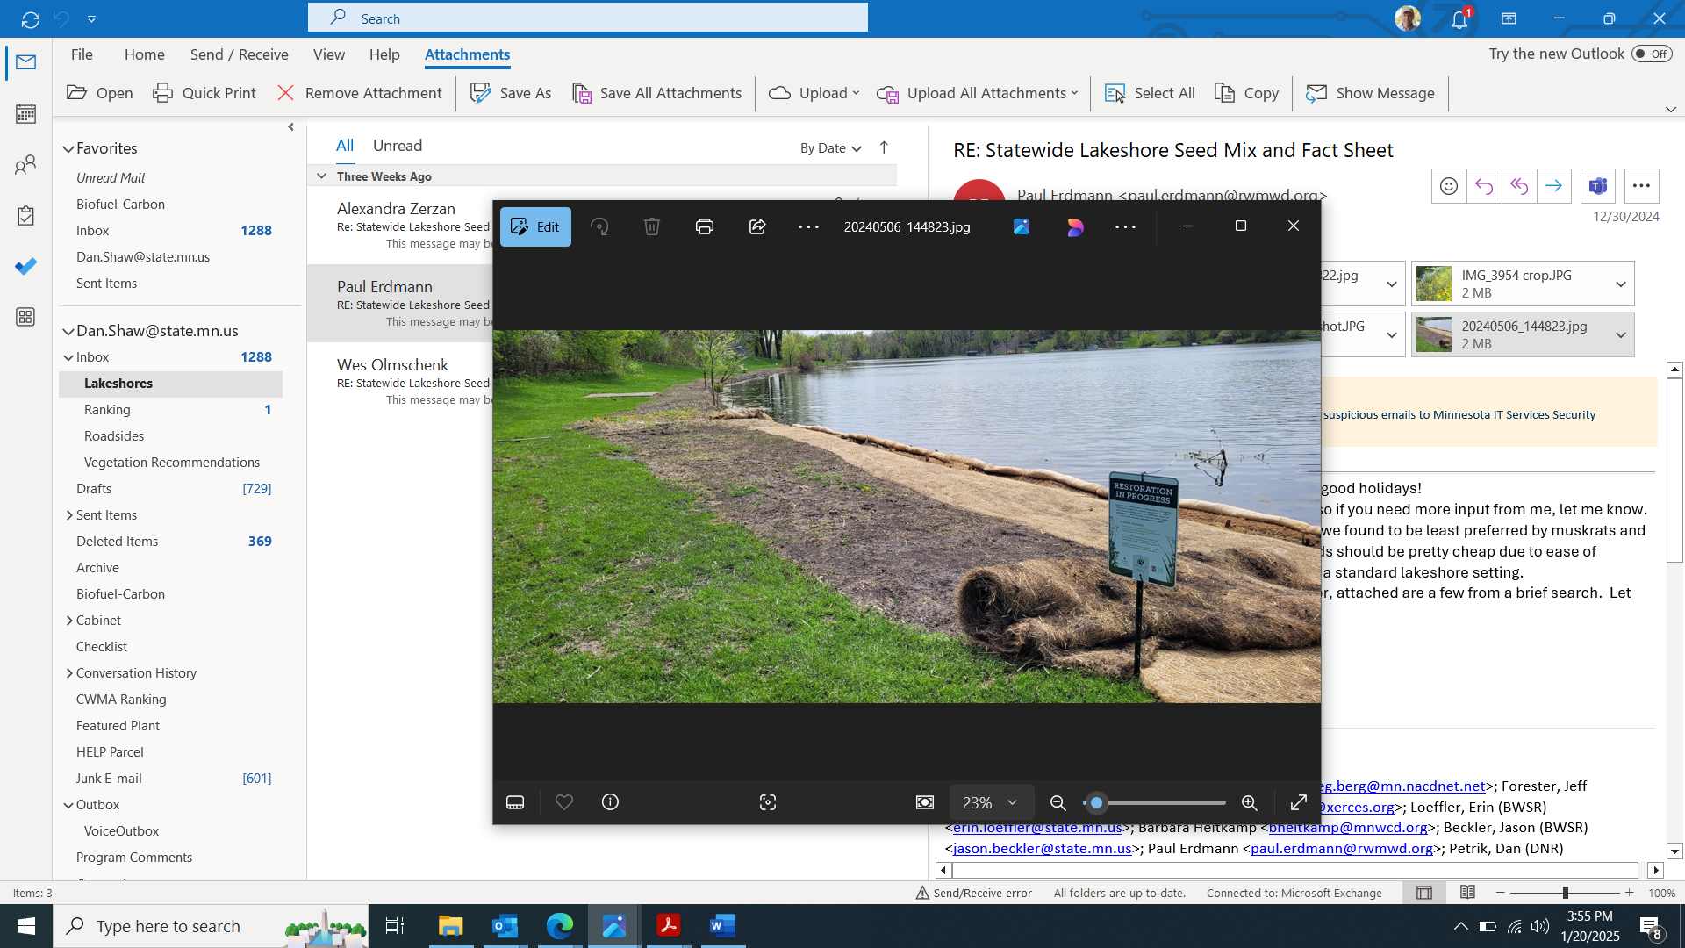

A prepared seedbed where erosion fabric is being applied after seeding

There may be some large lakeshore projects where native seed drills can be used such as large turf or agricultural field conversions. Seed drills require a smooth, firm seedbed. Soybean fields generally are sufficiently prepared for a native seed drill, but sites that were recently tilled will require additional soil treatment such as harrowing and rolling to prepare an adequate seedbed and prevent seed from being buried too deep. Broadcast seeding can be conducted on soybean or corn fields, or fields that have been disked, as long as the soil is allowed to settle before seeding. Some practitioners have found that broadcast seeding on a smooth surface (not tilled or disked) leads to the establishment of higher diversity. It is important that the soil surface is not too hard packed, so cultipacking or light harrowing of crop fields before broadcast seeding may be needed. Seed can be lost on smooth surfaces, so it is recommended to seed into temporary cover crops or to roll sites after seeding.

***Temporary Cover Crops and Mulch***

The use of short-lived temporary cover crops help stabilize project sites and minimize the need for additional mulch in preparation of planting native seed mixes. They can also provide time to observe weed problems, rebuild soil health, and to allow for proper weed control before fall seeding. Temporary cover crops such as oats or winter wheat (the two species most commonly used) should be mowed to 10-12 inches before seeds mature (or harvested upon maturity) to prevent re-seeding. Other cover crops typically used in agricultural fields, such as buckwheat, pennycress, and annual rye grass can help stabilize soil, build soil quality, or provide weed competition as part of restoration projects.

**Seeding Methods:** As noted under Seedbed Preparation, broadcast seeding is most often used for seeding lakeshores. Broadcast seeding can be conducted with seeding equipment or hand broadcasting which is common for smaller lakeshore projects. When hand broadcasting it is recommended to mix the tiny native plant seeds in a carrier such as sawdust or rice hulls to help ensure that seed is distributed evening over the entire site. The carrier and seed can be mixed thoroughly in buckets for spreading. For some sites it is helpful to separate the site into multiple areas and have buckets designated for each area. This approach helps ensure that seed can cover the entire project area. When hand broadcast seeding seed is simply tossed by had onto the soil surface. It is helpful to seed onto a couple inches of snow as it is easier to see which areas have been covered. The lakeshore seed mix has been designed with around 150 seeds per square foot. Many tiny shoreland seeds will not successfully germinate, so this seeding rate helps ensure that there will be successful establishment of native plants

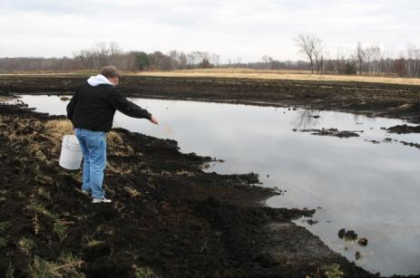

Hand broadcast seeding

For larger lakeshore areas native seed drills, no-till drills, Brillion seeders and Trillion seeders are all options for seeding. Specialized native seed drills can handle a wide variety of seed (fluffy, smooth, large and small) and low seeding rates, so they are also an option for shoreland seeding if they are calibrated correctly.

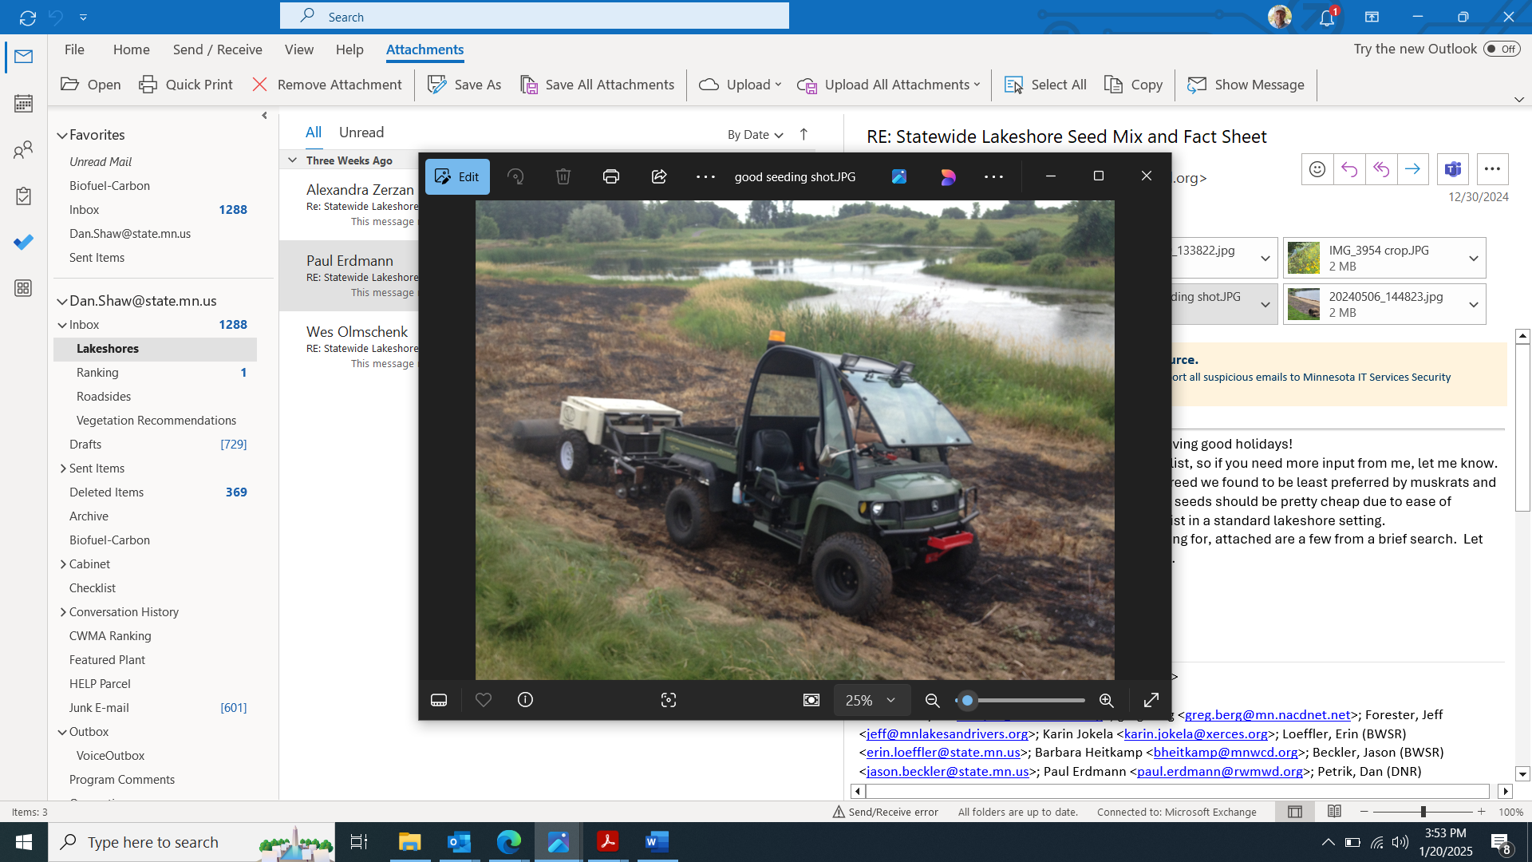

Seed drill behind a UTV

**Management Methods:**

*Establishment Mowing*

Establishment mowing or clipping of weeds may be beneficial for lakeshore plantings if the site conditions are not too wet for the equipment. Pressure from annual and biennial weeds is generally less with increased soil saturation and water depth. For smaller projects, brush cutters, string trimmers, or hand equipment can be used to target weeds and work around native plants. See the Minnesota Wetland Restoration Guide appendix: http://bwsr.state.mn.us/restoration/resources/documents/appendix-6a-3mowing.pdf

Mowing at least twice the first season and once the second season with a flail mower or stalk chopper (to prevent smothering plants) is often helpful to decrease competition and to provide sufficient sunlight for seedlings. Weeds should be mowed to between 5 and 8 inches before seed is allowed to set (usually as weeds reach 12-14 inches). Mowing height should be raised as native plants establish. The timing and frequency of mowing should be planned to allow sufficient light to reach native plant seedlings and preventing weed seed production. Sites with low weed competition due to sandy soils or other factors may not need mowing.

*Prescribed Burning*

Prescribed burning can be beneficial for some lakeshore plantings, particularly if burning was part of the historic plant community for the project. Burning can remove thatch, control invading woody and invasive plants, stimulate seed germination and new plant growth, and increase diversity in plantings. In some cases, the disturbance and increased nutrients from a burn can stimulate invasive reed canary grass germination, so this should be considered when the species is a risk for a project. Burning is typically initiated after the third or fourth years of establishment after native vegetation is reaching maturity. Burning is commonly conducted every three to five years. Fall and spring burns should be alternated periodically to simulate natural variation. Burn plans are needed to define the details of how the burn will be conducted, who will be involved and for contingency planning. In many cases, permits are also required. Partial burns and burns that are patchy may also benefit pollinator populations.

*Spot Treatment of Weeds*

Problematic perennial weeds that cannot be managed effectively with other methods may require spot treatment with herbicide or smothering with materials such as cardboard for sufficient control. Examples include reed canary grass, quack grass, purple loosestrife, Canada thistle, and Kentucky bluegrass. In some cases, herbicide treatment is not conducted during the first or second year of establishment to avoid impact to seedlings, but it may be important to control some weeds before they have a chance to spread. When using a broad-spectrum herbicide, it is important that an aquatic safe form is used near open water. When using herbicides, labels must be followed, and Personal Protective Equipment (PPE) must be used according to label instructions.

**What to Expect in Year 1:** During year one of growth many native grasses, sedges, rushes and flowers will remain about one to three inches tall. Short lived weeds such a ragweed, barnyard grass and foxtail grass may be common but not necessarily a cause for alarm. The mowing (around 5 to 8 inches) will play an important role to keep weeds managed so the native plant seedlings receive sufficient water and sunlight. The planting may have a somewhat weedy appearance this first year.

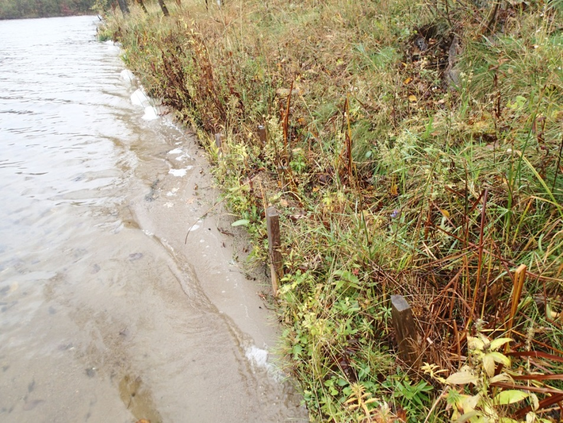

**What to Expect in Year 2:** During year two the native grasses and flowers may reach their mature height and some of them may flower. Mowing will still play a key role in managing weeds and allowing seedlings to grow.

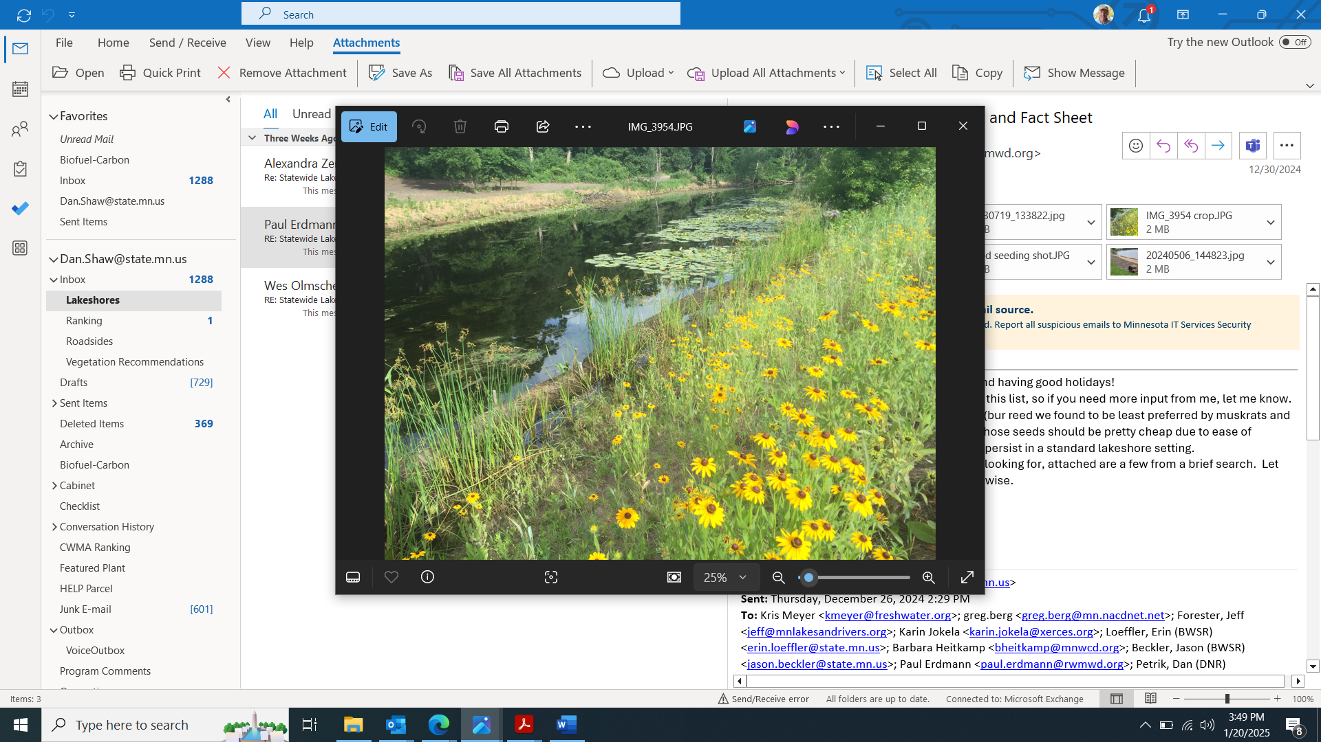

**What to Expect in Year 3 and Beyond:** By the end of year three most of the native plants will be nearing maturity and should flower. There may be some species that are slow to establish and may not show up for several years.

**Problem Solving**

*Poor Establishment After Year 1* – It is often difficult to determine if a seeding is successful during the first year as establishment may vary depending on weather conditions and some species may be slow to establish. It is typically best to wait until the second year to conduct any corrective actions.

*Poor Establishment After Year 2* – If native plant seedlings are not establishing about every one to two feet it may be necessary to inter-seed some species into the planting or add containerized plants.

*High Annual and Biennial Weed Competition* – Typically, annual and biennial weed competition is not a big problem in lakeshore plantings as they are short lived and as long as mowing is conducted before seed is set, they should not add additional seed into the planting.

*High Perennial Weed Competition* – Dense establishment of perennial species can be a problem as it can prevent the establishment of forbs. Herbicide application or smothering methods may be needed to manage perennial weeds.

*Low Forb Diversity After Year 3* – If grasses and sedges are establishing successfully but there is a lack of forbs it is recommended to conduct inter-seeding of additional forbs in late fall. See the [Xerces Society guide](https://xerces.org/publications/guidelines/interseeding-wildflowers-to-diversify-grasslands-for-pollinators) for additional information about inter-seeding wildflowers.