[Grab your reader’s attention with a great quote from the document or use this space to emphasize a key point. To place this text box anywhere on the page, just drag it.]

[Grab your reader’s attention with a great quote from the document or use this space to emphasize a key point. To place this text box anywhere on the page, just drag it.]

The Alliance to Advance Climate-Smart Agriculture incentivizes and rewards farmers and ranchers for adopting climate-smart agricultural practices such as cover crops, conservation crop rotation and nutrient management. **Earn $100 per acre or animal unit for incorporating approved practices into your farming operation.**

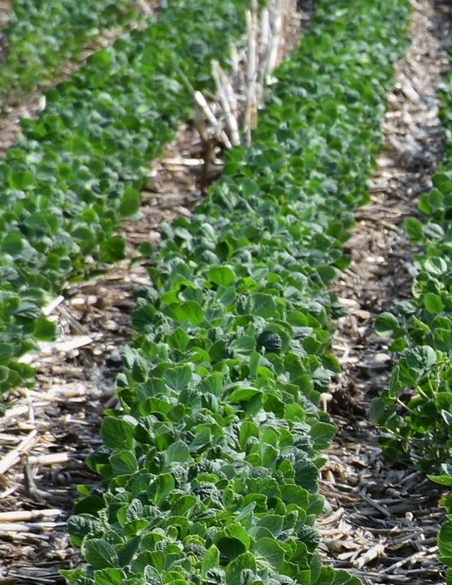

Event date

Event time

Location

**Questions?** Event contact here

**EVENT TITLE**