Riparian NE 34-362
Updated: 2022

This mix has been designed for riparian areas along rivers, streams and other waterbodies in northeast Minnesota with areas of moist soils and potential flooding during part of the growing season and full to partial sun where land is being converted from other uses such as agriculture or non-native grasses to riparian plants.

Partners also include stakeholder collaboration among Non-profits, Seed vendors, SWCD, Tribal Governments, Consultants, County and Cities. (see stakeholder list on website )

Common Name | Scientific Name | Rate (lb/ac) | % of Mix  (by weight) | % by Seed | Seeds/ sq ft
American slough grass | Beckmannia syzigachne | 0.65 | 2.19% | 8.28% | 12.00
bluejoint | Calamagrostis canadensis | 0.06 | 0.20% | 4.14% | 6.00
riverbank wild rye | Elymus riparius | 0.38 | 1.26% | 0.28% | 0.40
Virginia wild rye | Elymus virginicus | 1.30 | 4.35% | 1.38% | 2.00
tall manna grass | Glyceria grandis | 0.19 | 0.65% | 3.45% | 5.00
fowl manna grass | Glyceria striata | 0.08 | 0.25% | 1.72% | 2.50
rice cut grass | Leersia oryzoides | 0.08 | 0.27% | 0.69% | 1.00
fowl bluegrass | Poa palustris | 0.21 | 0.70% | 6.90% | 10.00
 | Grasses Subtotal | 2.95 | 9.87% | 26.83% | 38.90
bristly sedge | Carex comosa | 0.09 | 0.30% | 0.69% | 1.00
lake sedge | Carex lacustris | 0.02 | 0.08% | 0.07% | 0.10
pointed broom sedge | Carex scoparia | 0.10 | 0.33% | 2.07% | 3.00
tussock sedge | Carex stricta | 0.01 | 0.04% | 0.17% | 0.25
Common beaked sedge | Carex utriculata | 0.05 | 0.18% | 0.14% | 0.20
fox sedge | Carex vulpinoidea | 0.14 | 0.46% | 3.45% | 5.00
marsh spikerush | Eleocharis palustris | 0.03 | 0.11% | 0.41% | 0.60
path rush | Juncus tenuis | 0.03 | 0.09% | 6.90% | 10.00
dark green bulrush | Scirpus atrovirens | 0.09 | 0.30% | 10.35% | 15.00
woolgrass | Scirpus cyperinus | 0.02 | 0.08% | 10.35% | 15.00
 | Sedges & Rushes Subtotal | 0.58 | 1.97% | 34.59% | 50.15
Canada anemone | Anemone canadensis | 0.05 | 0.17% | 0.10% | 0.15
marsh milkweed | Asclepias incarnata | 0.23 | 0.76% | 0.28% | 0.40
nodding bur marigold | Bidens cernua | 0.06 | 0.22% | 0.34% | 0.50
common marsh marigold | Caltha palustris | 0.01 | 0.02% | 0.03% | 0.05
white turtlehead | Chelone glabra | 0.01 | 0.04% | 0.28% | 0.40
spotted water hemlock | Cicuta maculata | 0.05 | 0.15% | 0.14% | 0.20
flat-topped aster | Doellingeria umbellata | 0.03 | 0.11% | 0.55% | 0.80
common boneset | Eupatorium perfoliatum | 0.03 | 0.11% | 1.38% | 2.00
grass-leaved goldenrod | Euthamia graminifolia | 0.02 | 0.05% | 1.38% | 2.00
spotted Joe pye weed | Eutrochium maculatum | 0.06 | 0.19% | 1.38% | 2.00
autumn sneezeweed | Helenium autumnale | 0.10 | 0.35% | 3.45% | 5.00
giant sunflower | Helianthus giganteus | 0.02 | 0.07% | 0.06% | 0.08
Winged Loostrife | Lythrum alatum | 0.01 | 0.02% | 0.41% | 0.60
blue monkey flower | Mimulus ringens | 0.02 | 0.06% | 11.04% | 16.00
Virginia mountain mint | Pycnanthemum virginianum | 0.03 | 0.10% | 1.72% | 2.50
tall coneflower | Rudbeckia laciniata | 0.06 | 0.20% | 0.21% | 0.30
steeplebush | Spiraea tomentosa | 0.02 | 0.05% | 1.24% | 1.80
eastern panicled aster | Symphyotrichum lanceolatum | 0.03 | 0.12% | 1.38% | 2.00
red-stemmed aster | Symphyotrichum puniceum | 0.03 | 0.11% | 0.69% | 1.00
blue vervain | Verbena hastata | 0.18 | 0.59% | 4.14% | 6.00
golden alexanders | Zizia aurea | 0.25 | 0.83% | 0.69% | 1.00
 | Forbs Subtotal | 1.30 | 4.32% | 30.89% | 44.78
Oats | Avena sativa | 25.00 | 83.82% | 7.68% | 11.14
 | Cover Crop Subtotal | 25.00 | 83.82% | 7.68% | 11.14
 | Total | 29.83 | 99.98% | 100.00% | 144.97

Seed Mix Enhancements or Substitutions

List of Additional Species to Add Diversity or for Substitutions

The numbers (1-9) are species ranges that relate to the MN Ecological Subsection map found below.

Riparian Northeast
Updated 10-01-2022

Grasses:
Scientific Name | Common Name | Recommended Seeds per Square Foot
Bromus pubescens | Hairy Wood Chess | 2
Calamagrostis stricta (2,5,8,9) | Narrow Reedgrass | 2
Elymus villosus | Downy Wild Rye | 3
Glyceria canadensis (1,2,5,6) | Rattlesnake Grass | 2
Leersia virginica (6‐9) | White Grass | 2
Muhlenbergia racemosa | Marsh Muhly Grass | 1

Forbs:
Scientific Name | Common Name | Recommended Seeds per Square Foot
Cicuta maculata | Spotted Water Hemlock | 1
Gentiana andrewsii (3‐9) | Bottle Gentian | 3
Helenium autumnale (3,4,7‐9) | Helenium autumnale | 3
Helianthus grosseserratus (3,4,7‐9 | Sawtooth Sunflower | .5
Impatiens pallida (5‐8) | Pale Touch‐Me‐Not | 1
Lobelia spicata | Rough‐spiked Lobelia | 3
Lysimachia ciliata | Fringed Loosestrife | 2
Mentha arvensis (1-9) | Wild Mint | 3
Salix bebbiana (1-9) | Bebb’s Willow | 1
Salix discolor (1-9) | Pussy Willow | 1
Salix petiolaris (1-9) | Meadow Willow | 1
Symphyotrichum lanceolatum | Eastern Panicled Aster | .5
Teucrium canadense (1,4,6‐9) | Germander | 2

Sedges:
Scientific Name | Common Name | Recommended Seeds per Square Foot
Carex bebbii | Bebb's Sedge | .5
Carex brevoir | Short Sedge | .5
Carex emoryi | Emory's Sedge | .5
Carex haydenii | Hayden's Sedge | .5
Carex pellita | Wooly Sedge | .5
Juncus dudleyi | Dudley's Rush | 10
Juncus effusus (1,2,5‐7) | Soft Rush | 10

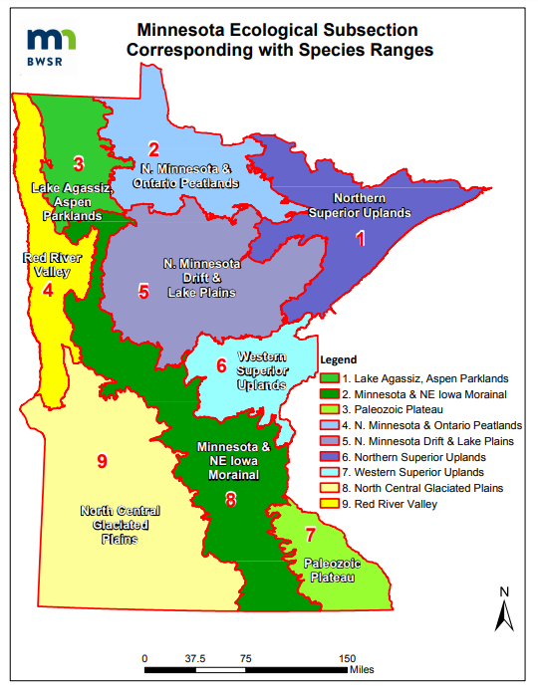

Riparian Northeast 34-362 Seed Mix Guidance

Seed mix name: Riparian Northeast 34-362 (Previously 34-362)
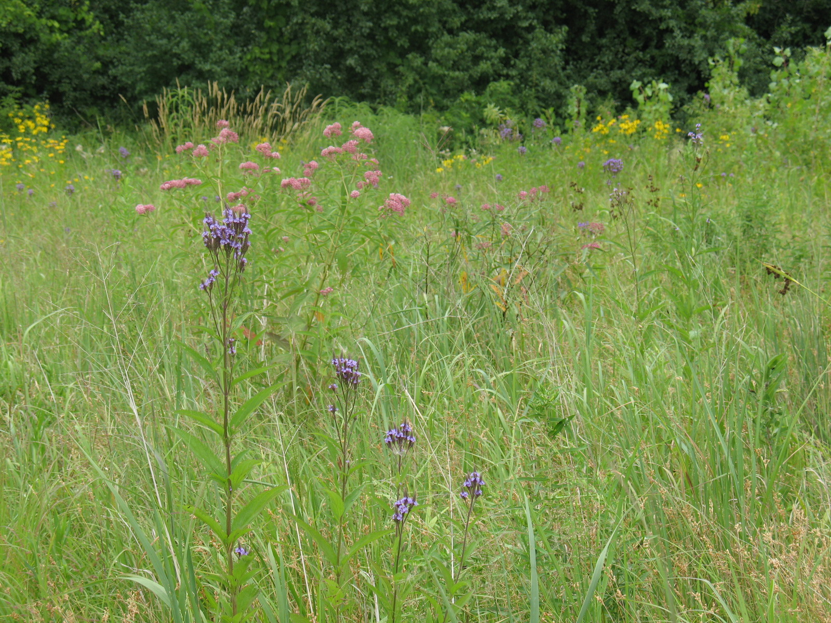
Geographic area: Northeast Minnesota
Year of development:2009
Year/s of update:
Status (Standard or Pilot mix): Standard
Primary and Secondary Functions:
Primary – Wildlife habitat, restoration of wetland functions, and water management
Secondary – Carbon Sequestration, emission reductions, pollinator habitat, songbird habitat
Similar State Mixes: Riparian South and West 34-262, Wet Meadow Northeast 34-372, Wet Meadow South and West 34-272
Compatible NRCS Practice Standards:
Compatible Minnesota CRP Practices:
Suitable Site Conditions: Riparian areas along rivers, streams and other waterbodies in northeast Minnesota with areas of moist soils and potential flooding during part of the growing season and full to partial sun where land is being converted from other uses such as agriculture or non-native grasses to riparian plants.
How to Modify for Site Conditions and Goals: This mix includes a list of additional species that can be considered to add species diversity. Site conditions such as sunlight, soils, hydrology and existing vegetation along with functional goals for the project such as carbon sequestration, pollinator habitat, and benefit to bird species can all have an influence on species selection and the modification of seed mixes. Additional plant species can also be added from containerized plants. It is also common that seed substitutions (see list) are used for wetland seed mixes when other species are not available.
Site Preparation: Primary goals for site preparation tend to focus on controlling weed species and providing ideal growing conditions for seed or plants to be installed. Site preparation methods vary depending on past uses of the site and the weed species that are present. The protection of microorganism populations and native seedbanks, preventing soil erosion, and managing weed establishment are all considerations during the site preparation process. In most cases, non-herbicide methods are preferred over herbicide intensive methods to protect aquatic organisms and soil microfauna, but herbicides may be the most efficient method of controlling some invasive perennial species. It is common for many conservation plantings to transition from corn or soybean production. Fields that are in agriculture often have control of most weeds. Another consideration is that several chemicals being used for weed control, along with herbicides (for herbicide-resistant crops) act as pre-emergents or post-emergents (designed to inhibit germination) and can be a problem for native vegetation establishment from seed. Investigate prior chemical use and labels to help define probability of having chemical carryover that could/should be addressed by using temporary cover crops to allow time for chemicals to break down. If a site is in perennial weeds such as smooth brome, quack grass or bluegrass and cannot be put into agricultural production for one or two seasons intensive site preparation may be needed. Herbicide application is often recommended, as tilling alone may re-suspend the rhizomes, allowing them to continue growing. For species such as reed canary grass and giant reed grass, cropping with chemicals that break down quickly, or combinations of mowing, herbicide application, prescribed burning, and tilling (or possibly additional herbicide application) may be needed. The Minnesota Wetland Restoration Guide provides detailed management recommendations for a wide range of species.

Seeding Dates:
Seed mixes for moist areas are most often installed in the fall after October 15th as a dormant seeding as most sedges, rushes and forbs need a winter to break their seed dormancy and start growing. It is also common to wait until shortly before snowfall to prevent the loss of seed from wind, birds and rodents. Snow seeding is conducted during early or late winter when there is less than four inches of snow, and on sunny days when seed can move to the soil surface. This technique has been successful for a wide variety of species types. Refer to the Minnesota Wetland Restoration Guide for more information about snow seeding. Seed can also be installed in the spring once soil temperatures reach 50 degrees Fahrenheit until June 30th but only a portion of the seed mix will germinate that first year. If a riparian project will be constructed in the spring/early summer or will have flowing or fluctuating water levels it may be better to seed later in the spring after water levels stabilize.

Seedbed preparation
Methods that are used to prepare a seedbed can vary depending on the type of seeding equipment to be used. If a traditional native seed drill will be used, a smooth, firm seedbed is required. Soybean fields generally are sufficiently prepared for a native seed drill, but sites that were recently tilled will require additional soil treatment such as harrowing and rolling to prepare an adequate seedbed and prevent seed from being buried too deep. Broadcast seeding can be conducted on soybean or corn fields, or fields that have been disked, as long as the soil is allowed to settle before seeding. Some practitioners have found that broadcast seeding on a smooth surface (not tilled or disked) leads to the establishment of higher diversity. It is important that the soil surface is not too hard packed, so cultipacking or light harrowing of crop fields before broadcast seeding may be needed. Seed can be lost on smooth surfaces, so it is recommended to seed into temporary cover crops or to roll sites after seeding.
Temporary Cover Crops and Mulch
The use of short-lived temporary cover crops help stabilize project sites and minimize the need for additional mulch in preparation of planting native seed mixes. They can also provide time to observe weed problems, and to allow for proper weed control before fall seeding. Temporary cover crops such as oats or winter wheat (the two species most commonly used) should be mowed to 10-12 inches before seeds mature (or harvested upon maturity) to prevent re-seeding. Slough grass (Beckmannia syzigachne) is a common cover crop for wet areas. Annual rye grass was commonly used but is generally avoided now due to its ability to inhibit germination of native species. Other cover crops typically used in agricultural fields, such as buckwheat, pennycress, and radishes, can help stabilize soil, build soil quality, or provide weed competition as part of restoration projects. Also see NRCS Agronomy Technical Note 31.
Seeding Methods
A variety of seeding equipment is used for riparian areas including broadcast seeders, traditional native seed drills, no-till drills, Brillion seeders and Trillion seeders. Broadcast seeders are most often used for seeding areas of moist soils as most of the seed is very small and needs to be near the soil surface to germinate. Brillion type seeders can also work well as they drop seed on the surface and then use a roller to ensure seed to soil contact. Specialized native seed drills can handle a wide variety of seed (fluffy, smooth, large and small) and low seeding rates so they are also an option for wetland seeding if they are calibrated correctly.
Management Methods –
Establishment Mowing
Establishment mowing may be beneficial for plantings if the site conditions are not too wet for the equipment. Pressure from annual and biennial weeds is generally less with increased soil saturation and water depth. For smaller projects, brush cutters, string trimmers, or hand equipment can be used to target weeds and work around native plants. See the Minnesota Wetland Restoration Guide appendix: http://bwsr.state.mn.us/restoration/resources/documents/appendix-6a-3mowing.pdf
Mowing at least twice the first season and once the second season with a flail mower or stalk chopper (to prevent smothering plants) is often helpful to decrease competition and to provide sufficient sunlight for seedlings. Weeds should be mowed to between five and eight inches before seed is allowed to set (usually as weeds reach 12-14 inches). Mowing height should be raised as native plants establish. The timing and frequency of mowing should be planned to allow sufficient light to reach native plant seedlings and preventing weed seed production. Sites with low weed competition due to sandy soils or other factors may not need mowing.
Prescribed Burning
Prescribed burning can be beneficial for some riparian plantings, particularly if burning was part of the historic plant community for the project. Burning can remove thatch, control invading woody and invasive plants, stimulate seed germination and new plant growth, and increase diversity in plantings. In some cases, the disturbance and increased nutrients from a burn can stimulate reed canary grass germination, so this should be considered when the species is a risk for a project. Burning is typically initiated after the third or fourth years of establishment, after native vegetation is reaching maturity. Burning is commonly conducted every three to five years. Fall and spring burns should be alternated periodically to simulate natural variation. Burn plans are needed to define the details of how the burn will be conducted, who will be involved and for contingency planning. In many cases, permits are also required. It is recommended to only burn one-half or less of a project site at a time if they are large (over 50 acres), or don’t have any adjacent refuge such as other conservation lands adjacent to the site for wildlife species. Partial burns and burns that are patchy may also benefit pollinator populations if timed correctly (when pollinators are not actively foraging or pollinators have pupated and are mobile).
Spot Treatment of Weeds
Problematic perennial weeds that cannot be managed effectively with other methods may require spot treatment with herbicide for sufficient control. Examples include reed canary grass, quack grass, purple loosestrife, Canada thistle, and Kentucky bluegrass. In some cases, herbicide treatment is not conducted during the first or second year of establishment to avoid impact to seedlings, but it may be important to control some weeds before they have a chance to spread. A common practice for Canada thistle control involves clipping seedheads while they are in the bud stage (usually early June) and conducting herbicide application with a broad-leaf specific herbicide in the fall (mid to late October). This timing limits the application of herbicide while pollinators are active. Grass-specific herbicides are used to control reed canary grass in wet meadow restorations, particularly on sites dominated by forbs and sedges that will not be affected. Grass-specific herbicides are most effective on young reed canary plants (6-12 inches tall) than on mature plants. There is some evidence that using surfactants along with herbicides and disking prior to application may improve effectiveness. It should be noted that grass specific herbicides are not aquatically certified and should not be used near open water. When using a broad-spectrum herbicide, it is important that an aquatic safe form of glyphosate and surfactant be used near open water. When using herbicides, labels must be followed, certified applicators must conduct the treatment and Personal Protective Equipment (PPE) must be used according to label instructions. Minimize herbicide first year/spot spray year 2. Unless significant problem weeds show up.
What to Expect in Year 1: During year one of growth many native grasses, sedges, rushes and flowers will remain about one to three inches tall. Agricultural weeds such a ragweed, barnyard grass and foxtail barley may be common but not necessarily a cause for alarm. The mowing will play an important role to keep weeds managed so the native plant seedlings receive sufficient water and sunlight. The planting may have a somewhat weedy appearance this first year.
(IMAGE)
What to Expect in Year 2: During year two the native grasses and flowers may reach their mature height and some of them may flower. Mowing will still play a key role in managing weeds and allowing seedlings to grow.
(IMAGE)
What to Expect in Year 3 and Beyond: By the end of year three most of the native plants will be nearing maturity and should flower. There may be some species that are slow to establish and may not show up for several years.
Problem Solving
Poor Establishment After Year 1 – It is often difficult to determine if a seeding is successful during the first year as establishment may vary depending on weather conditions and some species may be slow to establish. It is typically best to wait until the second year to conduct any corrective actions.
Poor Establishment After Year 2 – If native plant seedlings are not establishing about every one to two feet it may be necessary to inter-seed some species into the planting.
High Annual and Biennial Weed Competition – Typically, annual and biennial weed competition is not a big problem in wet meadow plantings as they are short lived and as long as mowing is conducted before seed is set they should not add additional seed into the planting.
High Perennial Weed Competition – Dense establishment of perennial species can be a problem as it can prevent the establishment of forbs. Herbicide application may be needed to manage perennial weeds.
Low Forb Diversity After Year 3 – If grasses and sedges are establishing successfully but there is a lack of forbs it is recommended to conduct inter-seeding of additional forbs in late fall. See the Xerces Society guide for additional information about inter-seeding wildflowers.

