Appendix 13: Watershed Planning

WRAPS and Local Water Plans
When BMPs are considered for drainage system projects, consideration should be given to the drained-land BMP needs identified in WRAPS reports and local planning strategies developed from the information provided in WRAPS. WRAPS include specific pollutant reduction targets in TMDLs needed to restore water quality so that standards are met. These plans and strategies also typically indicate the number of BMPs and associated acreages needing various types of drained-land BMPs, such as controlled drainage on slopes less than one percent, drainage waters treated in constructed wetlands, cover crops on tiled lands and geologically sensitive lands, and/or saturated buffers to treat drainage waters before discharging into ditches and streams.
When BMPs are needed on fields outside of the public drainage system to meet water quality goals, the public drainage system authorities for the project should inform land owners who use the public drainage system of the specific field BMP adoption goals for collectively achieving water quality objectives.
A “whole system” (drained agricultural lands and the ditch/tile 103E system) assessment of BMP needs and opportunities may also be available, completed by the drainage authority under a multi-purpose pre-petition planning effort. In such cases, the drainage authority will have current information that can meet both design and comprehensive environmental objectives for system change.

Water Quality Protection and Improvement
Minnesota’s approach to water management includes a plan to implement watershed-based planning efforts that will over the next 10 years result in locally-led water quality improvement plans.
The passage of Minnesota’s Clean Water Legacy Act (CWLA) in 2006 provided a policy framework and resources to state and local governments to accelerate efforts to monitor, assess, and restore impaired waters, and to protect unimpaired waters.
The CWLA and the recently established Clean Water Fund has changed how Minnesota approaches water quality, allowing a systematic approach in addressing impaired waters and protection efforts in unimpaired waters. Minnesota’s watershed program has rapidly evolved from a singular focus on TMDLs to a watershed approach that will lead to comprehensive restoration and protection strategies for each of the state’s major (HUC8) watersheds described in comprehensive watershed management plans (e.g., One Watershed One Plan). The Framework describes how Minnesota agencies streamline water management by systematically and predictably delivering data, research, and analysis and empowering local action (Figure 1-1).

Figure 1-1. Minnesota Water Management Framework
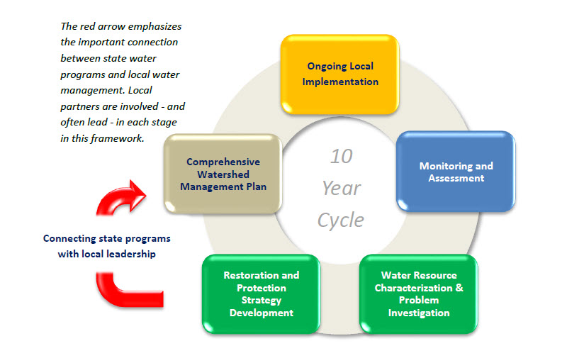
Ongoing Local Implementation is at the heart of the state’s overall strategy for clean water. Actions must be prioritized, targeted, and measurable in order to ensure limited resources are spent where they are needed most. The rest of the cycle supports effective implementation.
Monitoring and Assessment determines the condition of the state’s ground and surface waters and informs future implementation actions. The state’s “watershed approach” systematically assesses the condition of lakes and streams on a 10-year cycle. Groundwater monitoring and assessment is more varied in space and time.
Water Resource Characterization and Problem Investigationdelves into the science to analyze and synthesize data so that key interactions, stressors, and threats are understood. In this step, watershed and groundwater models and maps are developed to help inform strategies.
Watershed Restoration and Protection Strategies (WRAPS) and Groundwater Restoration and Protection Strategies include the development of strategies and high level plans, “packaged” at the 8-digit HUC scale (81 major watersheds in Minnesota). These strategies identify priorities in each major watershed and inform local planning. The required elements in every WRAPS are outlined in a statute linked here. The Comprehensive Watershed Management Plan is where information comes together in a local commitment for prioritized, targeted, and measurable action. Local priorities and knowledge are used to refine the broad-scale WRAPS and other assessments into locally based strategies for clean and sustainable water.
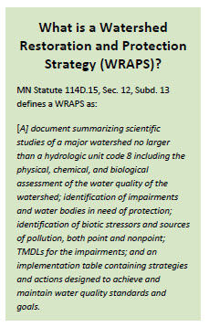
Many watershed pollutants manifest as problems downstream of the HUC8 watersheds in regional lakes, reservoirs, national waters and international waters. It is important, therefore, that comprehensive watershed management plans address the contribution of water volume and pollutants to waters within their HUC8 watershed as well as downstream waters.
Large-scale strategies for pollutants such as nutrients and sediment provide direction for protection efforts needed to protect downstream waters. Two examples of such strategies can be found at:
MPCA's Nutrient Reduction Strategy
MPCA's Sediment Reduction Strategy
Management and treatment of agricultural drainage waters are important elements of the nutrient and sediment strategy goal attainment. Broad scale adoption of BMPs outside and inside of the public drainage system are needed to meet water quality objectives.
Additional Background Information On Local Water Planning and Available Plans Minnesotans have developed an approach to water quality that requires a broad level of participation, across many communities and many scales. Because surface water quality is linked to land use and land management, which involves a diverse array of people and institutions, there is no “one stop shop” for water quality. To illustrate this important point, consider the complexity of Water Quality Goals for large basins such as the Red River or Minnesota River, where there are many tributaries, units of government, and landowners involved.
To address this complexity, Minnesotans have developed some practical tools that are being employed across our regions and watersheds. Implementation measures to restore and protect water quality are to be accomplished at the local and regional scales, including the watershed scale. During the last several decades, watershed-scale management has changed from something strictly done by watershed districts, to plans and actions by all local and state government. Public drainage systems play an important role in this process, as they are often in a headwaters position, where land and water management improvements will have multiple benefits. Benefits involving soil, water, and nutrients accrue for both the system itself, and to downstream water resources.
Several important aspects of Minnesota’s watershed approach for water quality can be found at:
•MPCA: Watershed approach to restoring and protecting water quality
•BWSR: Nonpoint Priority Plan for Clean Water Implementation Funding, Version 1.0. (July 2014 to June 2016)
The Nonpoint Priority Plan is important as it lays out a process for targeting CWF implementation money. It also provides a general process for prioritizing nonpoint restoration and protection work at multiple scales. It also provides tables and websites for examples of priority nonpoint implementation issues and approaches from recent state plans and laws.
Table 1 provides a summary of Minnesota’s water quality approaches, which should be accounted for in the Minn. Stat. § 103E.015 considerations for environmental, land use, and multipurpose water management. Drainage authorities and their consultants should be aware of what water quality-related documents and procedures are currently applicable to their watershed. This would involve both a review of pertinent documents and reports, and communication with local and regional water planning and management staff. A good place to start would be an overview of BWSR’s Drainage webpage, and a phone call to your county water planning staff person, and the MDNR’s regional environmental review specialist. Early communication between the drainage authority, the engineer, and the governmental entities involved with review, commenting and permitting, is critical to planning and executing a drainage project. Drainage authorities are encouraged to step forward and “fill-the-gap” between the landowners on the system, and the downstream regions and water resources, which are both affected by upstream land use and drainage system management.
Table 1

Water QualityProgram/Element | Authority | GovernmentLead Contact | Websites | Summary Description
County Water Management Plan | Minn. Stat. 103B | State: BWSR Counties | http://www.bwsr.state.mn.us/planning/CLWM/index.html | County-scaled plans for surface and groundwater protection and management. Review and approval by BWSR.
Watershed District Plan | Minn. Stat. 103D | Watershed Districts, BWSR | http://www.bwsr.state.mn.us/planning/index.html#watershed | There are 46 WDs in MN with authority to regulate, conserve and control water within a jurisdictional watershed boundary.
Soil and Water Conservation District Plan | Minn. Stat. 103C | County level SWCD; BWSR | http://www.bwsr.state.mn.us/partners/swcd/swcd.html | Plans and implements soil and water conservation practices with landowners, in cooperation with USDA.
Total Maximum Daily Loads (TMDL) | CWA 303(d) | MPCA | https://www.pca.state.mn.us/water/total-maximum-daily-load-tmdl-projects | Pollutant load allocations for both point and nonpoint sources to restore water quality to meet a standard.
Watershed Restoration and Protection Strategy (WRAPS) | Minn. Stat. 114D.15 | MPCA | http://www.pca.state.mn.us/index.php/water/water-types-and-programs/watersheds/watershed-overview-map.html | A compilation report for each HUC 8 watershed, including water quality goals and targets, with strategies, timelines and responsibilities.
One Watershed, One Plan | 2015 Session Law, Ch. 2 | BWSR and LGUs | http://www.bwsr.state.mn.us/planning/1W1P/index.html | A comprehensive watershed management plan approach, including soil health.

