BWSR Website Administrator’s Guide

BWSR Website Administrator’s Guide 1
Homepage Edits 1
Edit Hero image, text, button and button link. 1
Edit BWSR Updates 2
BWSR Features 4
BWSR Funding 4
Useful links – are a menu item 6
Images 6
Image Guidelines: file types, names, sizes 7
Featured Menu Items 7
Snapshot Newsletter, Featured Plant and Clean Water Fund Stories 8
ToolBoxes (Subcategory Landing Page) 9
Add Admins/Editors 11
People 12
People > add (a new) user 12
People > edit 12
Lockouts 12

Homepage Edits

Edit Hero image, text, button and button link.

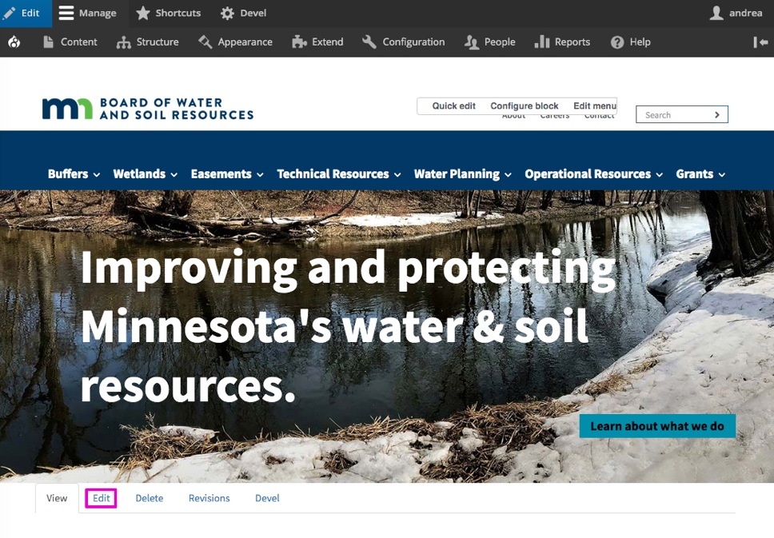

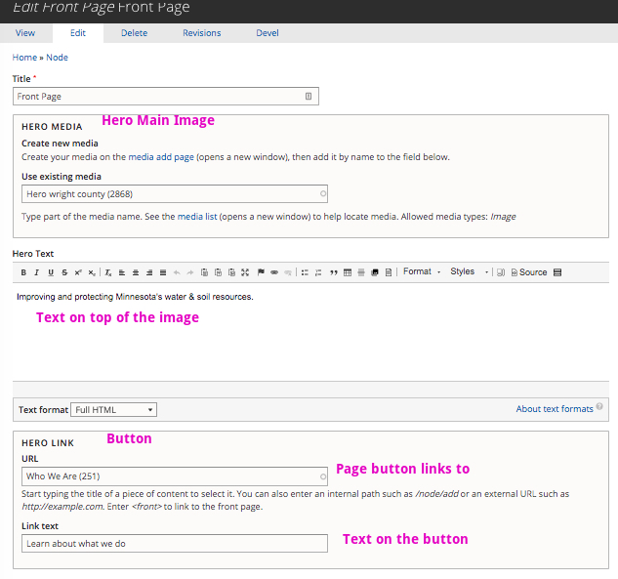

Edit BWSR Updates

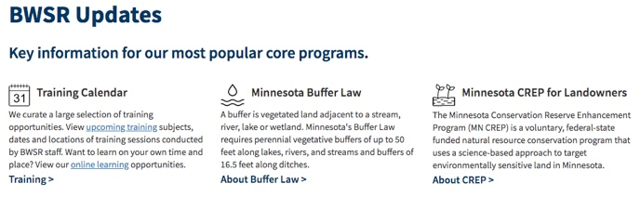

Image icon: 32 px wide x 32px high; download line art icons from istockphoto.com or graphicriver.net, noun project or similar.

Display: Only 3 will display at a time.

Add: Create the new node and publish. Then unpublish old. (Unclick Published button.)

The BWSR features section is a view that pulls in the three most recent published content type = Updates nodes. Access this content by navigating to Content and filtering by type: Updates. To edit, click the edit link.

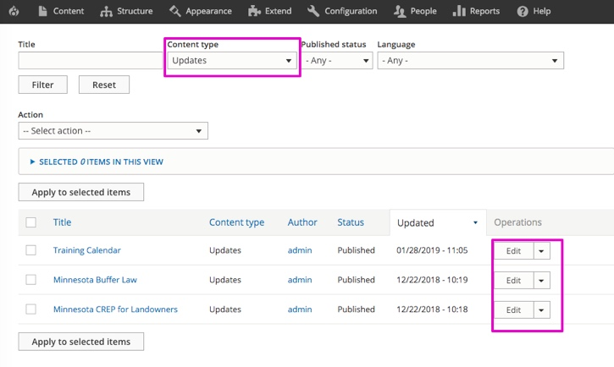
Fields on the form allow you to customize the title, body (text snippet), button link text and url link, and icon that sits to the left of the title.

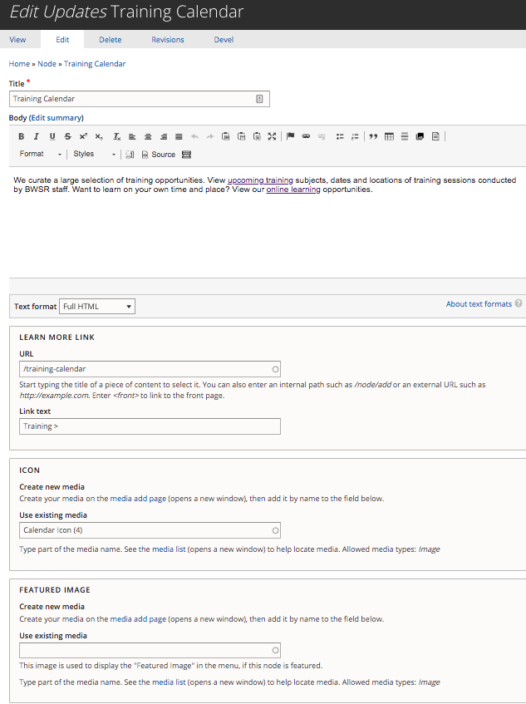

BWSR Features
The BWSR Features section is a view that pulls in the most recent content type nodes.

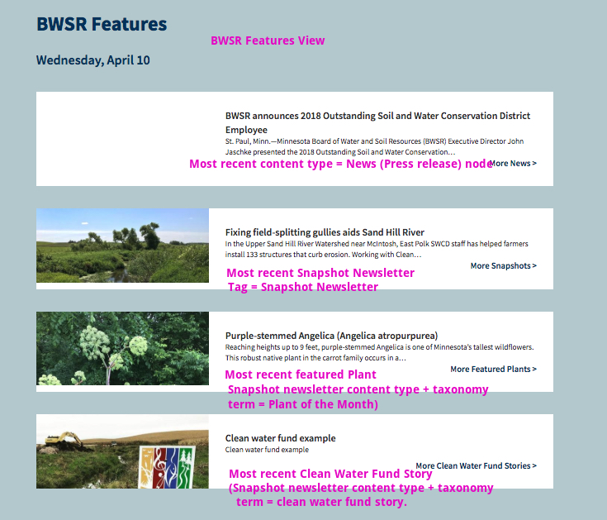

BWSR Funding
The BWSR Funding section is a view that pulls in the most recent content type = BWSR Funding nodes. They can be rearranged by date. The snippet of text above the graphic can be edited in the view.

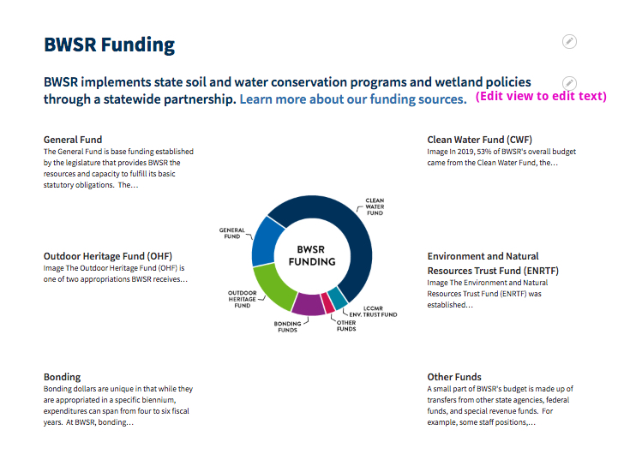

The background graphic can be edited in the media. The title is “Funding Graphic.”
http://bwsr.nighthawkmktg.com/media/2885/edit

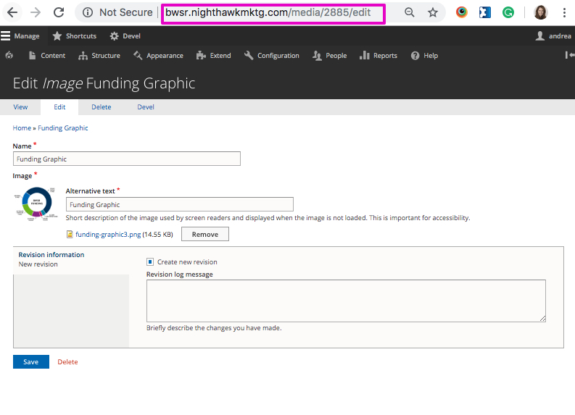

Useful links – are a menu item
Structure > Menus > Useful Links > Edit Menu > Add Links
Edit menu Useful Links
Drag & drop to reorder

Connect with Us block

Images
Images: resizing and quality, how to find previously saved images, will the code help us find image path?

To access images, go to Content > Media Images.

Save web optimized images. The pixel size to be used will be determined by the final size the image should be styled at. Inside pages are 700 px wide.

http://bwsr.nighthawkmktg.com/image-style-examples

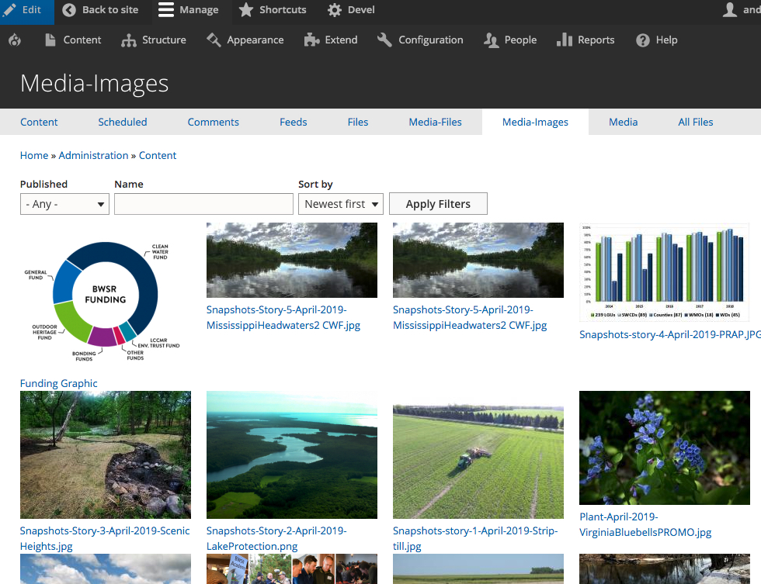

Image Guidelines: file types, names, sizes
- File types: Save images in .jpg, .gif, or .png format only.
- File name: Only use letters, numbers, underscores, and hyphens in file names.
- File size: For large size images, use image files of less than 200 KB for best results. Small and medium size images should be less than 100 KB.
- Main Hero Image (home page) – The main hero image width example: 1500 px by height: 400px; Drupal will crop the height of the photo at the bottom if the height of the photo used is greater than 400 px. This is an example file that could be used as a guideline. It is 192KB. http://bwsr.nighthawkmktg.com/sites/default/files/2019-03/APR-snow-Clearwater-River-WrightCounty-AW.jpg
- Snapshot Newsletter Images – Use an image at minimum 1500 width saved to web (low) resolution. Drupal will scale the image into the places where it is used.

Featured Menu Items

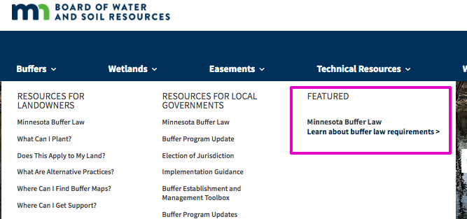

One page controls all the featured megamenu items. Go to Content and filter by content type = Featured Menu. The most recent node controls the featured megamenu (main nav) image, text and links. There are 7 main navigation (megamenu) items: Buffers, Wetlands, Easements, Technical Resources, Water Planning, Operational Resources, Grants. The “featured menu items” are in order on this one page and reference the corresponding featured menu items.

- Images in the featured items (in the main nav) are 220 px wide x 125 px high.

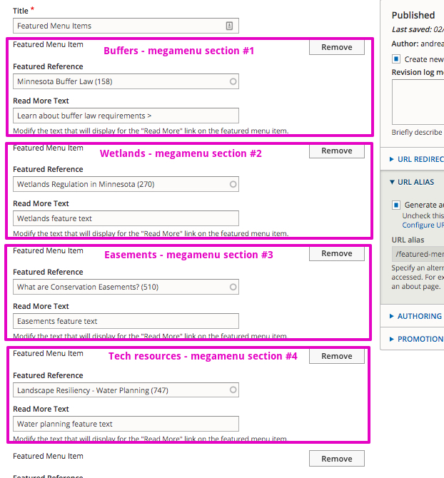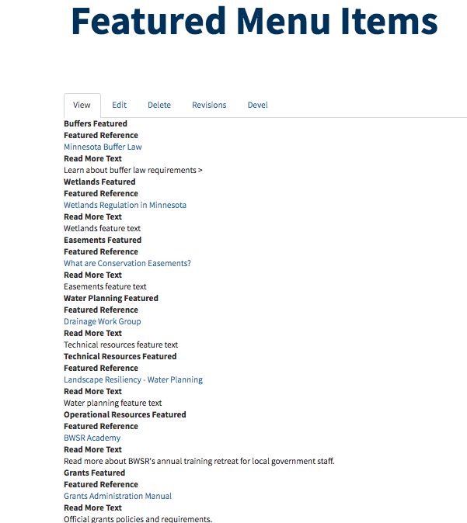

Snapshot Newsletter, Featured Plant and Clean Water Fund Stories
These are all content type = Snapshot newsletter with a tag pertaining to their content. (See home page tags.)

Locate + Edit: To locate these nodes, go to Content and filter by Snapshot Newsletter.
Add: To add a node, go to Content > Add Content > Snapshot Newsletter.
Tag: Snapshot Newsletter = Snapshot Newsletter; Clean Water Fund Story = Clean Water Fund; Featured plant = Plant of the Month. **Tags must be used so the home page brings in the most recent node.**

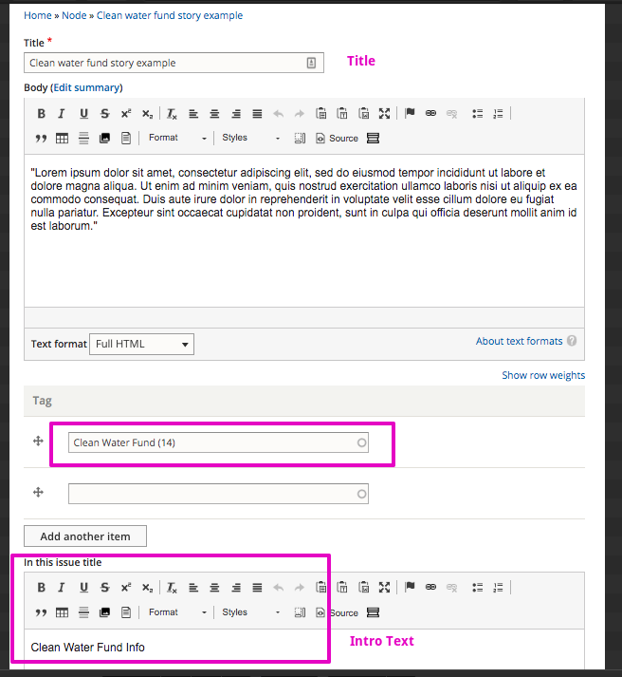

ToolBoxes (Subcategory Landing Page)
Toolboxes are content type = Subcategory Landing Page.
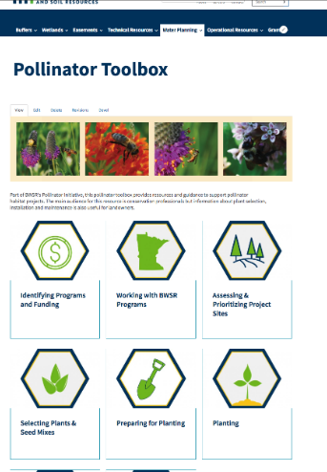

http://bwsr.nighthawkmktg.com/subcategory-example-page

Locate + Edit: To locate these nodes, go to Content and filter by Subcategory Landing Page.
Add: To add a node, go to Content > Add Content > Subcategory Landing Page.

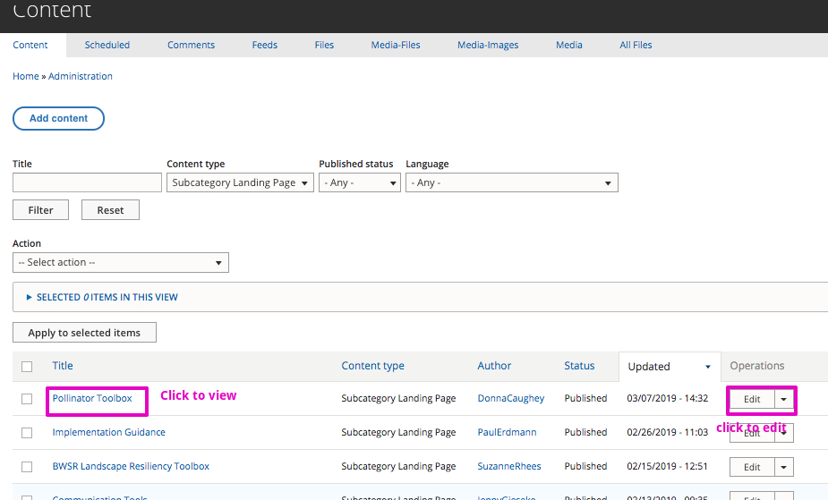

The Body section allows content (text) and images to be placed above the “cards.” The cards are node references that can reference basic page content.
Add card: To add a card, click the Add Subcategory button and fill in the page reference (name/title of page to reference, Page title (custom page title), image, and text if desired.
Remove card: Click the Remove button and confirm.
Rearrange: grab the crosshair icon next to the Subcategory and drag and drop up or down into position.

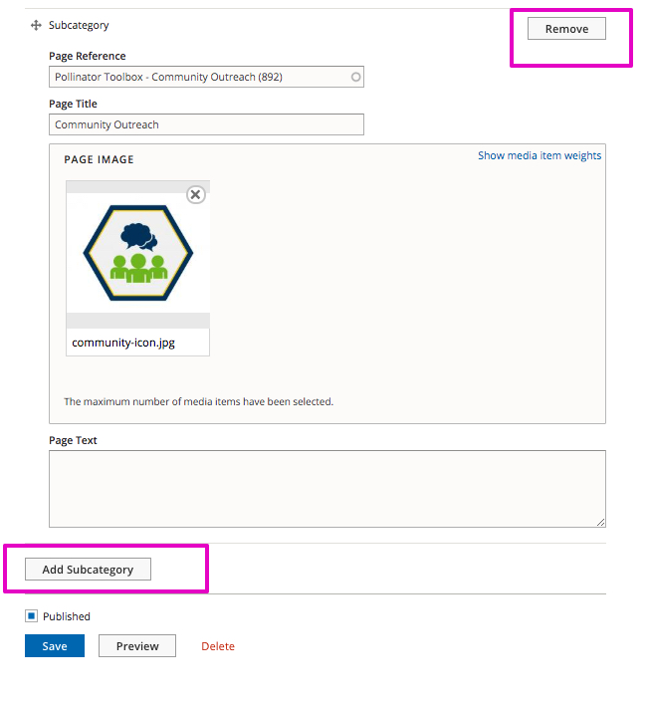
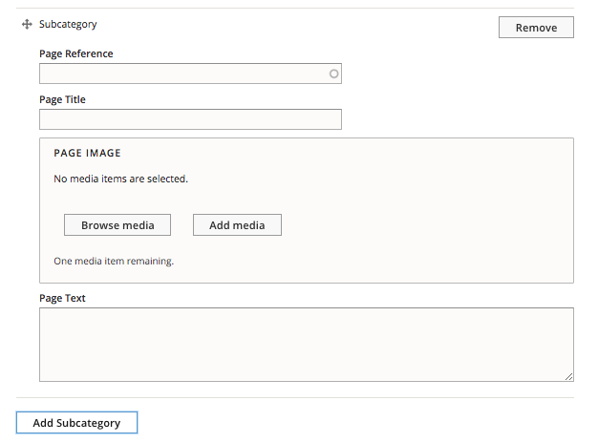

Add Admins/Editors

People - lists users and roles

People > add (a new) user
Name, email, role (admin or editor) > Create New Account.
People > Permissions shows differences between roles.

People > edit
Change/set new passwords

Lockouts
Configuration > System > Unblock (unblock users who have locked themselves out due to multiple login attempts.

