Why sign up for MN CREP?

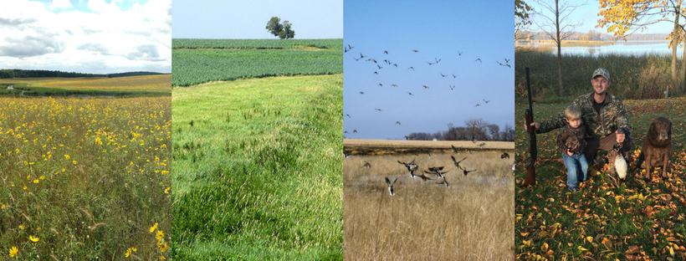
FAIR COMPENSATION: MN CREP combines USDA Conservation Reserve Program contract payments and Reinvest in Minnesota easement payments, covering at least 90 percent of the land’s value.
MARGINAL-CROPLAND FOCUS: MN CREP is an attractive option on land that produces lower yields because of wet ground, soil type or other challenges.
CCRP COMPARISON: Due to additional incentives paid through MN CREP, payments are 52 percent to 120 percent greater with MN CREP compared to CCRP.
FARM BILL UNCERTAINTY: The next Federal Farm Bill will expire Sept. 30 at the end of the federal fiscal year. Other cropland retirement options might not be available in future legislation.
CONSERVATION ELEMENTS: Enrolling land in MN CREP directly benefits water quality and creates new wildlife habitat.
LEGACY OPPORTUNITY: A MN CREP enrollment can help you create your legacy for future generations to enjoy.

For more information please contact:
Organization Name, Address, Phone, Website
