Pollinator Shade Low Meadow Mix 38-132
Updated: 2023
Areas of residential properties with direct, unfiltered sunlight for no less than 5 hours each day and slightly mesic (in between dry and wet) soils. These soils should be well- to moderately well-drained, good infiltration, and not have standing water for greater than 24 hours. Due to a higher cost than some native seed mixes the mix is recommended for plantings up to three acres in size.

This seed mix was a collaboration with Ecologist Stephen Thomforde. Partners also include collaboration among Non-profits, Seed vendors, SWCD, Tribal Governments, Consultants, County and Cities. (See partner list on website)
 | 38-132 | Pollinator Shade Low Meadow Mix
Code | Common Name | Scientific Name | PLS lb/ac | % by PLS lb/ac | Seeds/ft2 | % by Seeds/ft2
bougra | Blue Grama | Bouteloua gracilis | 1.00 | 5.13% | 14.69 | 25.60%
elytra | Slender Wheatgrass | Elymus trachycaulus | 0.80 | 4.10% | 2.03 | 3.53%
fesrub | Creeping Red Fescue | Festuca rubra | 1.06 | 5.44% | 11.05 | 19.25%
fessub | Nodding Fescue | Festuca subverticillata | 0.05 | 0.26% | 0.37 | 0.64%
passmi | Western Wheatgrass | Pascopyrum smithii | 0.24 | 1.23% | 0.63 | 1.09%
 |  | Grasses Subtotal | 3.15 | 16.15% | 28.76 | 50.12%
carbla | Eastern Woodland Sedge | Carex blanda | 0.04 | 0.21% | 0.18 | 0.32%
carbre | Plains Oval Sedge | Carex brevior | 0.16 | 0.82% | 1.70 | 2.97%
 |  | Sedges & Rushes Subtotal | 0.20 | 1.03% | 1.89 | 3.29%
allcan | Wild Garlic | Allium canadense | 0.15 | 0.77% | 0.03 | 0.05%
allste | Prairie Onion | Allium stellatum | 0.11 | 0.56% | 0.44 | 0.77%
anecyl | Thimbleweed | Anemone cylindrica | 0.02 | 0.10% | 0.19 | 0.33%
anevir | Tall Thimbleweed | Anemone virginiana | 0.05 | 0.26% | 0.51 | 0.90%
aqucan | Wild Columbine | Aquilegia canadensis | 0.07 | 0.36% | 0.98 | 1.70%
clavir | Spring Beauty | Claytonia virginica | 0.02 | 0.10% | 0.18 | 0.31%
dalpur | Purple Prairie Clover | Dalea purpurea | 0.13 | 0.67% | 0.72 | 1.25%
diccuc | Dutchman's Breeches | Dicentra cucullaria | 0.01 | 0.05% | 0.06 | 0.11%
germac | Wild Geranium | Geranium maculatum | 0.04 | 0.21% | 0.07 | 0.13%
rosark | Prairie Wild Rose | Rosa arkansana | 0.03 | 0.15% | 0.01 | 0.02%
sancan | Bloodroot | Sanguinaria canadensis | 0.02 | 0.10% | 0.01 | 0.02%
solfle | Zig Zag Goldenrod | Solidago flexicaulis | 0.03 | 0.15% | 0.93 | 1.61%
solnem | Gray Goldenrod | Solidago nemoralis | 0.05 | 0.26% | 5.51 | 9.60%
solpta | Upland White Goldenrod | Solidago ptarmicoides | 0.09 | 0.46% | 2.12 | 3.69%
symcor | Blue Wood Aster | Symphyotrichum cordifolium | 0.02 | 0.10% | 1.03 | 1.79%
symeri | Heath Aster | Symphyotrichum ericoides | 0.03 | 0.15% | 2.20 | 3.84%
symlae | Smooth Blue Aster | Symphyotrichum laeve | 0.05 | 0.26% | 1.01 | 1.76%
symlat | Calico Aster | Symphyotrichum lateriflorum | 0.03 | 0.15% | 2.75 | 4.80%
symser | Silky Aster | Symphyotrichum sericeum | 0.06 | 0.31% | 0.57 | 1.00%
thadio | Early Meadow Rue | Thalictrum dioicum | 0.04 | 0.21% | 0.11 | 0.19%
vioped | Prairie Violet | Viola pedatifida | 0.03 | 0.15% | 0.31 | 0.54%
zizapt | Heartleaf Alexanders | Zizia aptera | 0.07 | 0.36% | 0.31 | 0.54%
 |  | Forbs Subtotal | 1.15 | 5.90% | 20.06 | 34.95%
cover | Oats/Winter Wheat | Avena sativa/Triticum aestivum | 15.00 | 76.92% | 6.68 | 11.65%
 |  | Cover Crop Subtotal | 15.00 | 76.92% | 6.68 | 11.65%
 |  | Total | 19.50 | 100.00% | 57.39 | 100.00%

Bareroot plants or plugs to supplement your planting
Scientific Name | Common Name | Bloom Time | Sun/Shade | Range | Notes
Carex eburnea | Ivory Sedge | e/m | Part Shade, Shade | NE,SW,SE,NE
Carex pensylvanica | Pennsylvania sedge | e/m | Sun, Part Shade | NE,SW,SE,NE
Danthonia spicata | poverty oats | m/l | Sun, Part Shade | NE, NW
Allium canadense | Wild garlic | m | Sun | SE, SW, NE
Allium stellatum | Prairie onion | m | Sun | NE,SW,SE,NE
Anemone canadensis | Canada anemone | e | Sun, Part Shade | NE,SW,SE,NE | Aggressive spreader; good ground cover
Anemone cylindrica | Thimbleweed | m | Sun, Part Shade | NE,SW,SE,NE
Anemone patens | pasqueflower | e | Sun, Part Shade | NW,SW,SE
Anemone virginiana | Thimbleweed | m | Part Shade | NW,SW,SE,NE
Antennaria neglecta | pussytoes | e/m | Sun, Part Shade | NW,SW,SE,NE
Aquilegia canadensis | Wild columbine | e/m | Part Shade, Shade | NW,SW,SE,NE
Asclepias tuberosa | butterfly milkweed | m/l | Sun | SE, NE
Campanula rotundifloria | Harebell | m/l | Sun, Part Shade | NW,SE, NE,
Castilleja coccinea | Indian paintbrush | e/m | Part Shade | NW,SE,NE
Castilleja sessiliflora | Downy painted cup | e/m | Sun | NW,SW,SE
Chamaecrista fasciculata | Partridge pea | m/l | Sun, Part Sun | SW, SE
Claytonia virginica | spring beauty | e/m | Part Shade | NE
Dicentra cucullaria | Dutchmen's breeches | e/m | Part Shade, Shade | SE, SW, NE
Enemion biternatum | False rue anemone | e/m | Part Shade, Shade | SE
Erigeron pulchellus | Robin's plantain | e/m | Part Shade, Shade | SE,NE
Fragaria virginiana | Wild strawberry | e/m | Sun, Part Shade | NW,SW,SE,NE
Galium boreale | Northern bedstraw | m/l | Sun, Part Shade | NW,SW,SE,NE
Gentiana puberulenta | Downy gentian | l | Sun | NW, SW, SE
Geranium maculatum | wild geranium | e/m | Sun, Part Shade, Shade | NW,SW,SE,NE
Geum triflorum | Prairie smoke | e/m | Sun | NW,SW,SE, NE
Heuchera richardsonii | Alumroot | e/m | Sun, Part Shade | NW,SW,SE,NE
Liatris aspera | Rough blazingstar | m/l | Sun, Part Shade | NW,SW,SE,NE
Liatris ligulistylis | Meadow blazingstar | m/l | Sun | NW,SW,SE,NE
Lithospermum canescens | Hoary puccoon | e/m | Sun, Part Shade | NW,SW,SE,NE
Mertensia virginica | Virginia Blue Bells | e/m | Part Shade, Shade | SE
Monarda punctata | Spotted bee balm | m/l | Sun | SE
Pediomelum esculentum | Prairie turnip | e/m | Sun | NW,SW, SE
Pycnanthemum virginianum | Virginia mountain mint | m/l | Sun, Part Shade | NW,SW,SE,NE
Rosa arkansana | Prairie rose | m | Sun, Part Shade | NW,SW,SE,NE
Sanguinaria canadensis | Bloodroot | e | Part Shade, Shade | NW,SW,SE,NE
Sisyrinchium campestre | Blue-eyed grass | e/m | Sun | NW,SW,SE,NE
Symphotrichum oblongifolium | Smooth Blue Aster | l | Sun | NW,SW, SE
Symphyotrichum novae-angliae | New England aster | l | Sun, Part Shade | NW,SW,SE,NE | optional
Symphyotrichum sericeum | Silky aster | m/l | Sun, Part Shade | NW, SW, SE
Thalictrum dasycarpum | Purple meadow rue | m | Sun, Part Shade | NW,SW,SE,NE
Thalictrum thalictroides | Rue anemone | e/m | Part Shade, Shade | SE
Tradescantia bracteata | Prairie Spiderwort | m | Sun, Part Shade | NW,SW,SE
Tradescantia occidentalis | Western Spiderwort | m/l | Sun, Part Shade | NW, SE
Viola palmata var. pedatifida | Prairie violet | e/m | Sun, Part Shade | NW,SW,SE
Viola pedata | Birdfoot violet | e/m | Sun, Part Shade | SE
Viola spp. | Violets | e/m | Part Shade | NW,SW,SE,NE

*Plants look best grouped in 3's and 5's if you want a more manicured look.
early
Mid
Late

Pollinator Shade Low Meadow Mix 38-132 Guidance

Seed mix name: Pollinator Shade Low Meadow 38-132
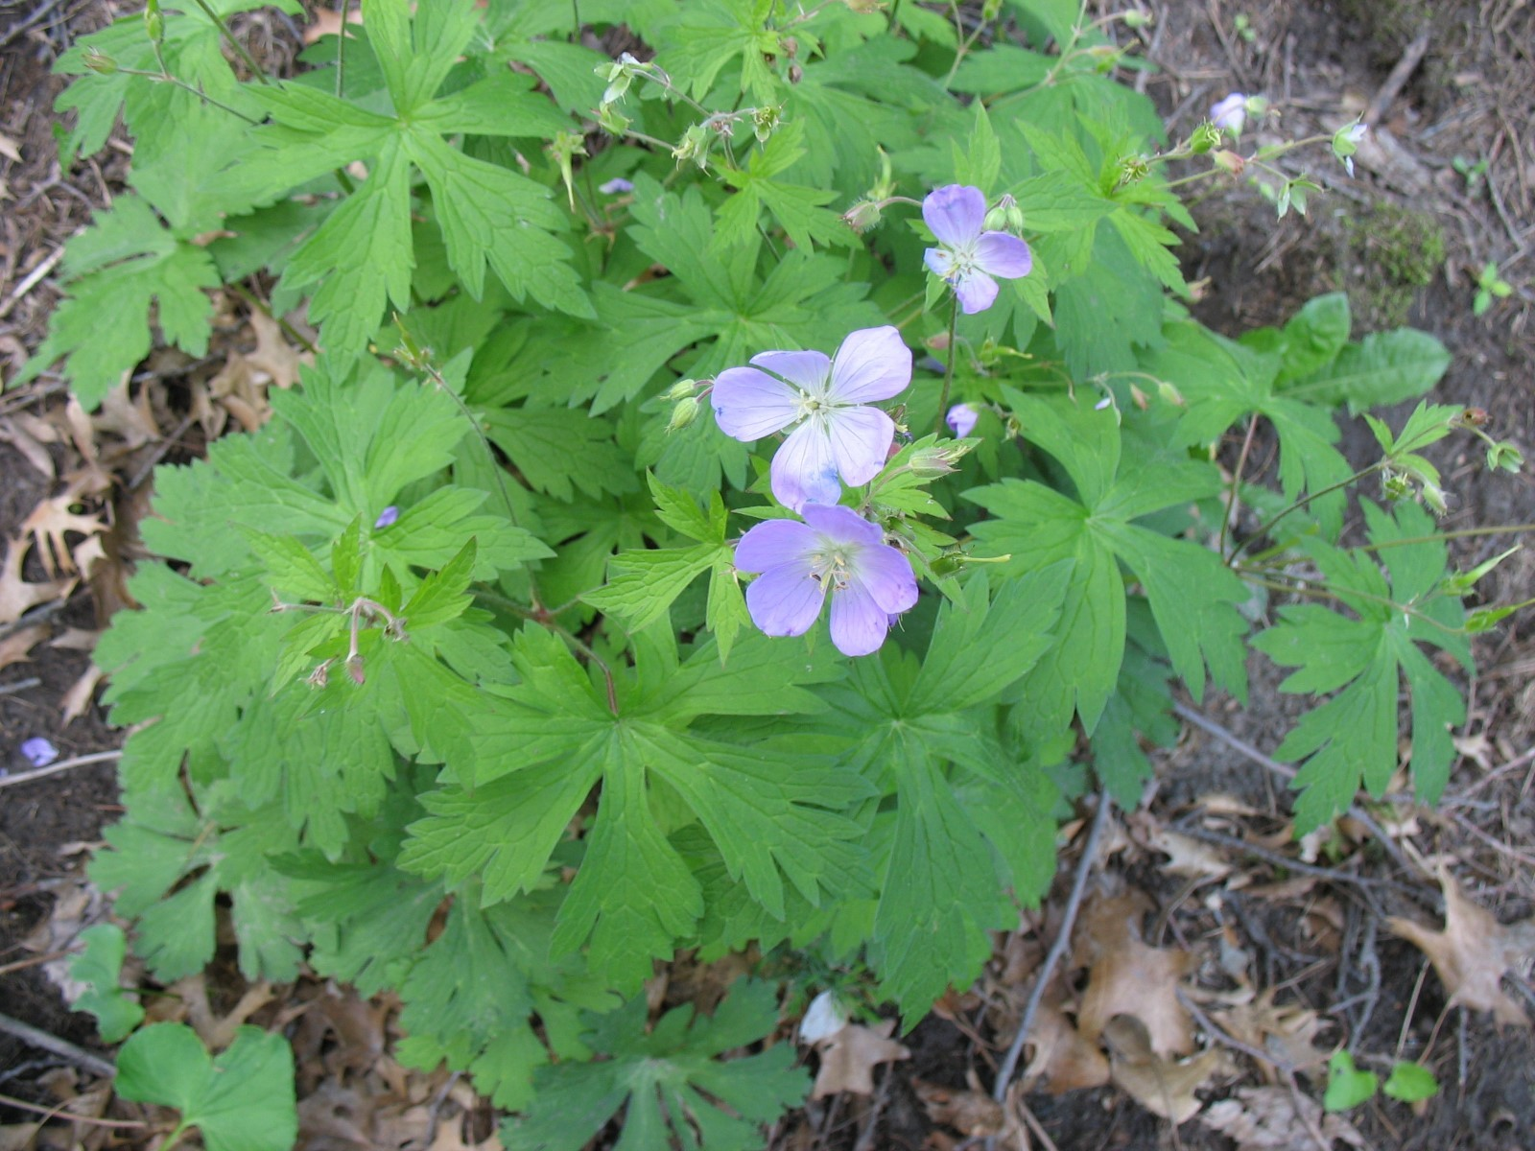
Geographic area: Minnesota, Statewide
Year of development: 2022
Year/s of update: 2022
Status (Standard or Pilot mix): Pilot
Primary and Secondary Functions:
Primary – Pollinator habitat
Secondary – Carbon sequestration, emission reductions, songbird & wildlife habitat, clean water (water filtration, recharging groundwater, reduced nutrient and sediment erosion), improved soil health
Similar State Mixes: Pollinator Sun Low Meadow
Suitable Site Conditions: Areas of residential properties with direct, unfiltered sunlight for no less than 5 hours each day and slightly mesic (in between dry and wet) soils. These soils should be well- to moderately well-drained, good infiltration, and not have standing water for greater than 24 hours. Due to a higher cost than some native seed mixes the mix is recommended for plantings up to three acres in size.
Site Planning: For residential plantings it is recommended to check city ordinances for any restrictions for vegetation height. It is also good to consider the residential context for the planting when considering its location and size and to incorporate “cues for care” into the landscape such as fences, walkways, edging, walls, signs and other features that create a sense of order and explanation for the project location.
How to Modify for Site Conditions and Goals: This mix includes a list of supplemental plants that can be added as plugs (seedlings germinated and grown in trays similar to garden 6-packs, but with a more developed root system), bareroot, or larger container individuals to increase diversity (selecting a wide variety of plants from different families and functional groups or guilds) or fit microclimates such as areas with additional shade or moisture. These species are recommended for this type of installation as they tend to have lower success from seed.
Installation Methods: Two methods of installation can be conducted, either preparing and seeding into a prepared seedbed or seeding into existing poor-quality turf with exposed bare soil. It should be noted that seeding into existing sod will result in some Kentucky bluegrass and other turf grasses persisting and is not successful when there is a dense sod established.
Prepared Seedbed – There are different methods for removing existing sod prior to seeding including the use of a sod cutter or sod kicker for removal or using clear plastic or cardboard to suppress vegetation for a season. See the Xerces Society guide to organic site preparation methods for more information. Planting dates will vary depending on the weather in a particular year and where the planting site is located (e.g., northern Minnesota versus southern Minnesota). Consult with native seed suppliers or restoration specialists to determine the best planting dates for that year. Seeding should be conducted in late fall (when soil temperatures are consistently below 50 degrees F, generally after October 15th, until soils are frozen) but can also be conducted in the spring or early summer, but this may result in delayed establishment of some forbs that need a winter freeze-thaw cycle to break their seed coat. Once existing vegetation is controlled, the soil surface should be lightly loosened, no deeper than 1/8” to ¼”, either using cover crops or mechanical methods such as a rake or drag implement prior to seeding. If you are planning to seed directly into the temporary covers, make sure to start with a cut rate (half amount) (20lbs/ac or less of oats) so there is enough exposed soil for good seed to soil contact when broadcasting native seeds. If there is not enough soil exposure, an additional herbicide application or haying of the cover crops may be needed prior to seeding to maximize success. Seed should be broadcast on top of the soil vs. being installed with a drill and can be lightly raked in. Rain or snowfall will then help create seed to soil contact. A light layer of prairie straw or weed free straw can help with germination and moisture retention.
Poor Quality Turf – When seeding into poor quality turf the lawn should be mowed as low as possible prior to seeding. The soil surface should also be harrowed or raked to loosen the upper surface. Make sure some of the soil surface is exposed so the seeds can get good seed to soil contact. Seeding should be conducted in the same manner as for a prepared seedbed.
Management Methods – The ideal management for this seed mix is to conduct periodic mowing and removal of clippings to replicate historic grazing patterns and to help remove excess nitrogen, which can favor undesirable weeds. Mowing frequency will depend on the preferred aesthetic, species selected, location, and project placement. “Spot mowing” (using a weed whip or other cutting implement) is recommended to allow for flowers to bloom and replicate grazing patterns. Mowing should not be conducted before temperatures are consistently above 50° F as there are many pollinators that nest in standing stems of flowers or grasses and emerge throughout the growing season in response to warming air temperatures and photoperiod cycles (day and night lengths). Mowers should be raised as high as they go, ideally 4 – 6 inches, though weed whips, sickles or scythes can also be used. The management of individual plantings should be tailored to the neighborhood context and homeowner’s judgement. Occasional spot spraying of herbicide maybe needed in year three for continued management of hard to remove invasive species. Mowing is a good way to control some species such as thistles, but other methods are needed to control species such as Poison Hemlock, Common Tansy, Leafy Spurge, Spotted Knapweed, Wild Carrot and Wild Parsnip. If there are large areas of these species, it would be helpful to minimize the disturbance of site preparation. There are helpful guidelines in the manual Restoration-Guide-Invasive-Perennial-to-Conservation-Prairie.pdf (nature.org).
Educational Signs – Including signs in front of plantings is encouraged to communicate the intent of the planting and encourage other homeowners to take on similar projects. Some example signs can be found here.

What to Expect in Year 1: During year one of growth many native grasses and flowers will remain about one to three inches tall while others can grow to maturity depending on the site conditions. The mowing/clipping will play an important role for managing weeds and preventing tree seedlings from taking over. It will also help the native plant seedlings to receive sufficient water and sunlight. Mowing may need to be more frequent to keep weeds below eight inches tall. The planting may have a slightly weedy appearance this first year.
(IMAGE)
What to Expect in Year 2: During year two the native grasses and flowers may reach their mature height and some of them may flower. Spot mowing will still play a key role in managing weeds and allowing seedlings to grow. Hand-pulling of select weeds and tree seedlings is also beneficial.
(IMAGE)
What to Expect in Year 3 and Beyond: By the end of year three, most of the native plants will be nearing maturity and should flower. There may be some species that are slow to establish and may not show up for several years. Hand-pulling tree seedlings is also beneficial throughout the life of the planting to maintain a meadow appearance.
Problems Solving
Poor Establishment After Year 1 – It is often difficult to determine if a seeding is successful during the first year as establishment may vary depending on weather conditions, site conditions like soils and slope, climate patterns, and individual species development (some species are slower to develop than others). It is typically best to wait until the second year to conduct any corrective actions.
Poor Establishment After Year 2 – If native plant seedlings are not establishing about every two feet it may be necessary to inter-seed or install containerized plants of some species into the planting. If this is a concern it is recommended to have a professional inspect the site and recommend what species could be supplemented. Inter-seeding should be conducted in spring or late fall and can be conducted by lightly loosening the soil surface with a rake followed by broadcast seeding. Make sure some of the soil surface is exposed so the seeds can get good seed to soil contact. Some light packing with a garden roller or other methods may be beneficial.
High Annual and Biennial Weed Competition – Typically, annual and biennial weed competition is not a big problem in plantings as these weeds are short-lived. Mowing to control these species should be conducted before seed is set so they do not add additional seed into the planting. Even if mowing cannot be achieved, these species typically drop out of the planting or lessen in density as the planting advances in age and some, like foxtail, are also providing excellent food for wildlife.
High Perennial Weed Competition – Dense establishment of perennial species can be a problem as it can prevent the establishment of forbs. It is recommended to clip back undesirable perennial species low to the ground and smother them if possible. They can also be dug out, but this may cause disturbance to native plant seedlings nearby, requiring some reseeding.
Low Forb Diversity After Year 3 – If grasses and sedges are establishing successfully, but there is a lack of forbs it is recommended to conduct inter-seeding of additional forbs in late fall. Plugs or bare-root flowers can also be planted in early to mid-spring or late fall when there is good soil moisture.
Animal Grazing- In small projects and often in residential areas, browsing by deer and/or rabbits can impact native plant establishment. Some grazing can be prevented by using natural grazing deterrents that are applied to plants and/or the ground surrounding plants. These natural deterrents emit an odor or make plants unpleasant for these herbivores. Wire cages or fencing can also be placed to prevent grazing while plants establish. Once the planting is established it is better able to withstand grazing pressure.

