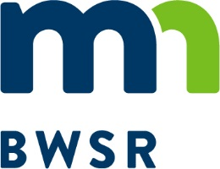
2021 Partnership Project RFP
Application Checklist

Partner Name: |  | County:
Note: All forms listed below in bold italics can be found on the BWSR website under wetland banking:
https://bwsr.state.mn.us/local-government-road-wetland-replacement-program

REQUIRED FORMS AND DOCUMENTS

Application Checklist (this form)
Partnership Project Plan (including all required maps and attachments)
Conservation Easement Landowner Questionnaire and Easement Area Assessment Form
Attachment A Affidavit of Noncollusion
Attachment B Certification Regarding Lobbying

If the application area contains or abuts any existing CRP contracts, conservation easements, or public lands, submit the following document:

Aerial photo identifying locations/boundaries of identified CRP contracts or other easements/public lands. Other easements should be clearly marked as to which type (i.e. USFWS, WRP, RIM, etc.)
If the application area contains or abuts any Public Waters or Public Water Wetlands, submit the following document:
Aerial photo identifying location and name or number designation of Public Waters and Public Water Wetlands.

Other information/comments:

