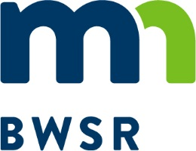
2021 Agricultural Wetland Bank
Technical Assistance Program
Fact Sheet

Description
In response to continued high demand for agricultural bank (Ag Bank) credits, BWSR is seeking landowners interested in restoring wetlands to work cooperatively with BWSR to establish additional wetland banks in select areas of the State. The purpose of this program is to increase the availability of wetland credits by reducing the risk and uncertainty of the wetland bank establishment process to interested landowners utilizing BWSR’s expertise and institutional knowledge.

Through a competitive evaluation process BWSR will identify projects that will receive technical and administrative support in the form of engineering design, plan development, agency coordination, and post-construction technical and administrative support. Landowners will be responsible for construction, monitoring, and post-construction site management. All credits resulting from the projects will be deposited into a State Wetland Bank account managed by the landowner. The landowner is required to make the credits available to USDA program participants in need of wetland mitigation credits for compliance purposes at a price established by the landowner. All proceeds from credit sales will be the landowners. Landowners are not required to reimburse BWSR for the costs associated with the technical and administrative support.

This program is anticipated to have an open application period throughout calendar year 2021. However, applications will be reviewed and evaluated three times during the year at the following cut off dates: April 7, August 31, and December 31. Based on the results of the evaluations BWSR will move ahead with project development activities as determined by program need and agency resources. If a sufficient number of projects are identified in the first or second application periods an announcement may be made indicating that no additional projects are needed, and the application period may be terminated prior to December 31, 2021.

Eligible Sites
BWSR is seeking to restore wetlands on the landscape that have been lost as a result of drainage or fill. To meet program requirements and maximize the amount of credits generated by the restoration, eligible sites should meet the following criteria:

- Restorable areas must be Prior Converted (PC) or Non-Wetland (NW) according to a NRCS Certified Wetland Determination (CWD). Sites with restorable wetlands that also contain Wetland (W), Farmed Wetland (FW), or Farmed Wetland Pasture (FWP) according to the CWD will still be considered if they are a small percentage of the restorable wetland. However, the area encompassed by one of these wetland labels will not receive credit;
- Wetlands must have been historically present at the site and the physical characteristics of the site will allow for hydrologic and/or vegetative restoration to take place;
- Previously restored wetlands through the Conservation Reserve Program (CRP) with contract expiration dates between 2019 – 2022;
- Because of limits in state and federal wetland banking rules, a majority (more than 50%) of the acres within the proposed easement area should be restorable wetlands;
- The characteristics of the site and the proposed easement boundary should support an upland buffer adjacent to planned restored wetlands that is a minimum width of 25 feet and an average width of 50 feet;
- The property must be free of other easements or legal agreements that may conflict with or serve the same purpose as the wetland banking easement;

Targeted Geographic Areas
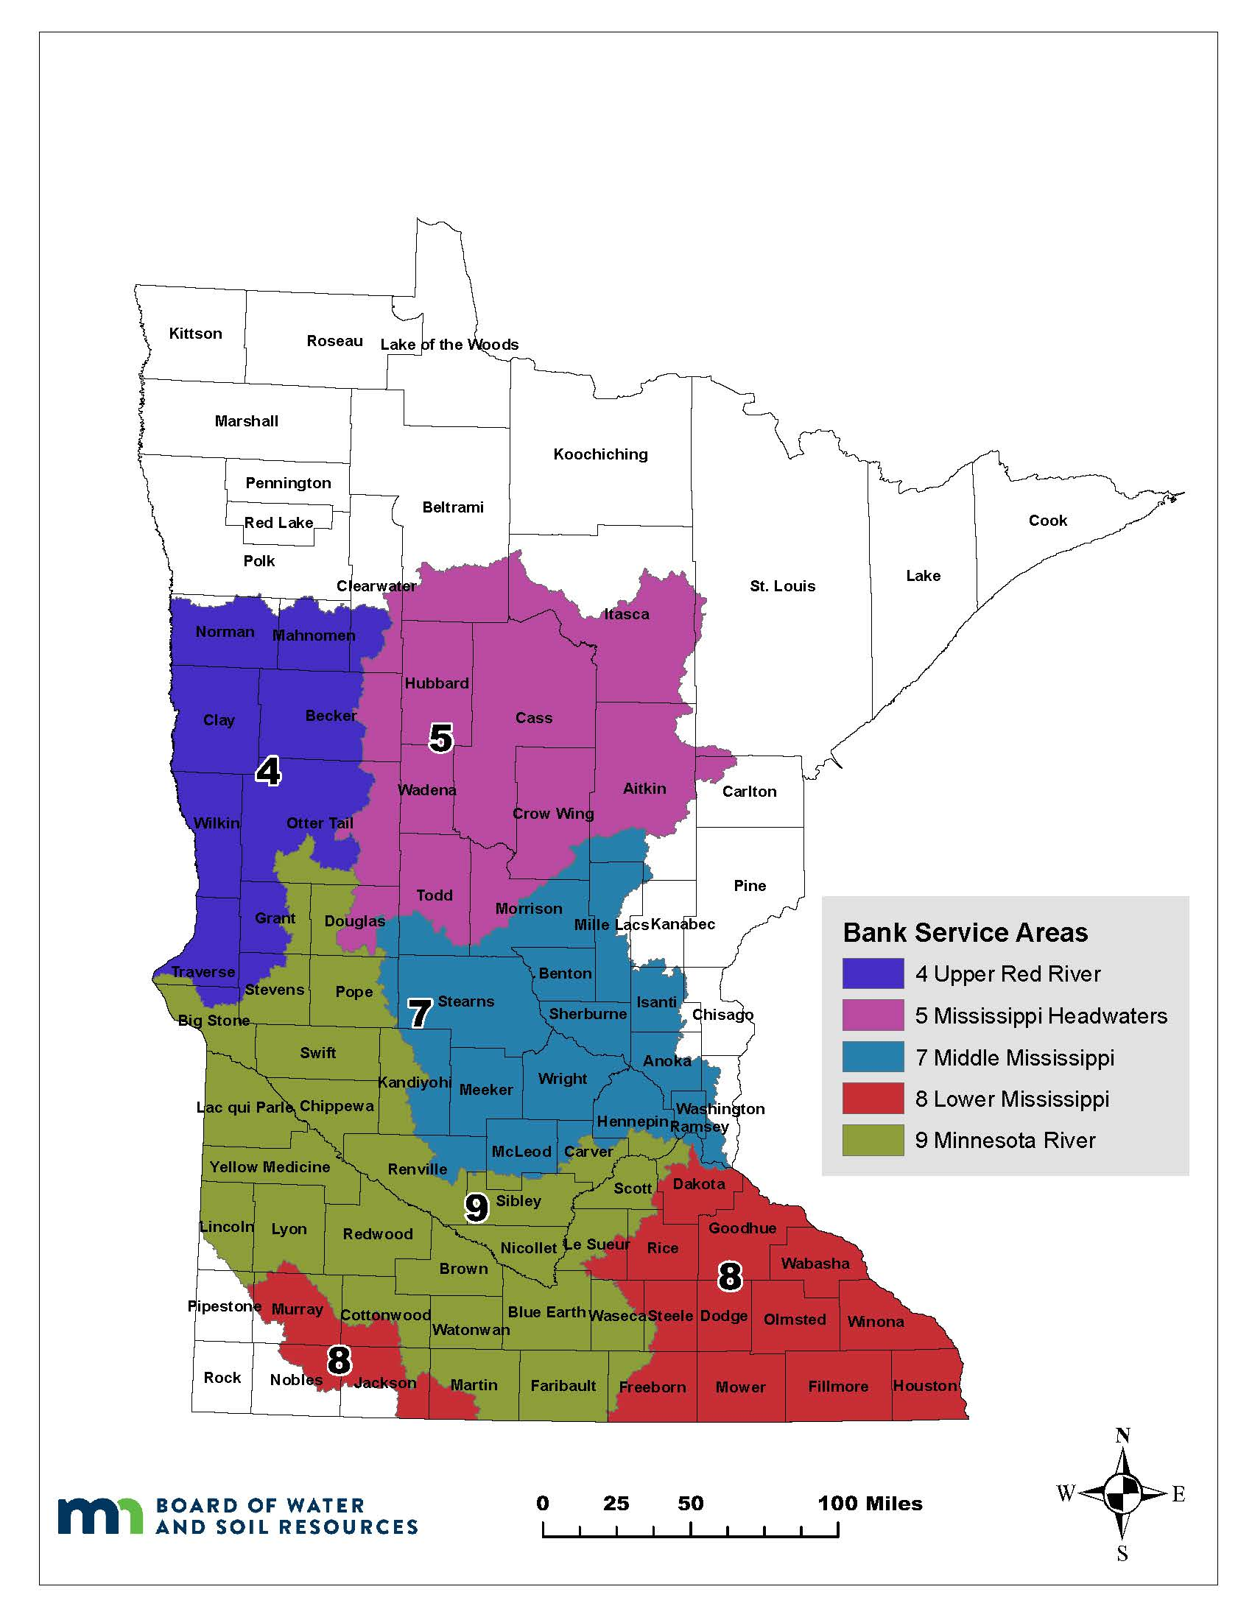
Five bank service areas (BSAs) have been identified as priorities for the Technical Assistance program. They include the Upper Red River (BSA 4), Mississippi River Headwaters (BSA 5), Middle Mississippi River (BSA 7), Lower Mississippi River (BSA 8), and the Minnesota River (BSA 9). The targeted BSAs are shown on Figure 1. This includes all or portions of the following counties: Aitkin, Anoka, Becker, Big Stone, Blue Earth, Benton, Beltrami, Brown, Carlton, Carver, Cass, Chippewa, Clay, Clearwater, Cottonwood, Crow Wing, Dakota, Dodge, Douglas, Faribault, Fillmore, Freeborn, Grant, Goodhue, Hennepin, Houston, Hubbard, Isanti, Itasca, Jackson, Kanabec, Kandiyohi, Lac qui Parle, Le Sueur, Lincoln, Lyon, Mahnomen, Martin, McLeod, Meeker, Mille Lacs, Morrison, Mower, Murray, Nicollet, Nobles, Norman, Olmstead, Otter Tail, Pipestone, Pope, Ramsey, Redwood, Renville, Rice, Scott, Sherburne, Sibley, St. Louis, Stearns, Steele, Stevens, Swift, Todd, Traverse, Wabasha, Wadena, Waseca, Washington, Watonwan, Wilkin, Winona, Wright, and Yellow Medicine.
Figure 1.

Evaluation Criteria
Applications will be evaluated using the following criteria. The percentage in parentheses is the contribution of the criterion towards the total score for the project:

- Technical Feasibility (25%)
- Credit Yield (25%)
- Landscape Benefit (20%)
- Historically Underserved (15%)
- Credit Cost (15%)

Number of Applications Selected to Participate in the Program
A set number of projects has not been identified for this program. BWSR has a goal of establishing one new Ag Bank in each targeted BSA. The total number of projects selected will depend on the location, size, and technical complexity of the applications submitted along with available BWSR staffing resources.

Anticipated Schedule
The steps in the review and selection process relevant to the landowner/applicant are provided below:

- First application period end date April 7, 2021
- First application period evaluation results and notifications completed June 1, 2021
- Second application period end date August 31, 2021
- Second application period evaluation results and notifications completed October 1, 2021
- Final application period end date December 31, 2021
- Final application period evaluation results and notifications completed February 1, 2022

Depending on characteristics of the site and weather conditions, a field inspection/investigation may take place during the review of submitted applications. For selected sites, BWSR staff will conduct additional investigations to collect the information necessary to complete the restoration plan for the site. Landowners may continue to utilize their property (cropping, haying, etc.) during this period. BWSR only requests that applicants allow the agency reasonable access to the site.

Landowner Responsibilities
Once an application has been selected BWSR staff will work with the landowner to develop a schedule for the project including an estimated date when the physical work associated with the wetland restoration should begin. The tasks associated with development of a wetland mitigation bank and the party responsible for each task under this program are provided in Table 1 below. As indicated in the table, BWSR assumes all responsibility for completing the site design, mitigation plan, and agency coordination. Once BWSR receives approval of the final mitigation plan the landowner will be provided with a copy of the approved mitigation plan and the engineering construction plans. At this point the landowner assumes responsibility for constructing the project, monitoring it through the establishment period, and conducting any additional management activities. BWSR staff will be available to answer questions about the design or requirements in the mitigation plan but the primary responsibility for project implementation lies with the landowner.

Table 1.
Project Development Tasks | Responsible Party
Mitigation Plan Development, Engineering Survey & Design, Pre-Project Wetland Delineation, Construction Staking & Oversight, Marketing of Credits | BWSR
Easement Acquisition, Construction, Vegetation Establishment, Monitoring, Wetland Bank Fee Payments, Post-Project Wetland Delineation, Post-Construction Site Management | Landowner

Application Process
Landowners interested in the Minnesota Ag Bank Technical Assistance Program must submit the application materials listed below. All application forms are available on the BWSR webpage.

Application Checklist
Application Form
Questionnaire and Easement Area Assessment Form
Crop History and Land Use Form

Landowners needing assistance with preparing an application may contact their local Soil and Water Conservation District staff or the BWSR point of contact identified on this notice.

BWSR Point of Contact
Questions can be directed to Kane Radel - Wetland Mitigation Specialist, kane.radel@state.mn.us, (507) 537-7069.

For lands that do not have a CWD, the original NRCS wetland determination can be submitted in the interim.

