Why sign up for MN CREP?

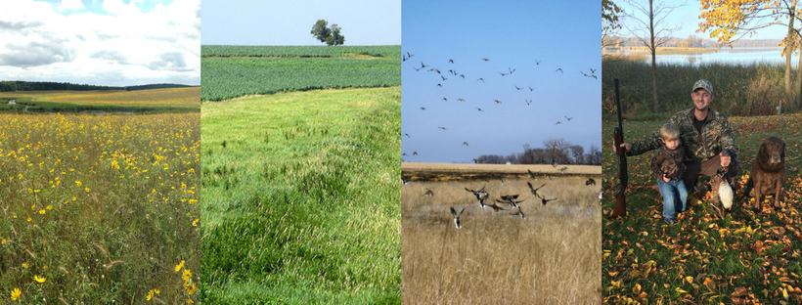
FAIR COMPENSATION: MN CREP combines USDA Conservation Reserve Program contract payments and Reinvest in Minnesota easement payments, covering at least 90 percent of the land’s value.
MARGINAL CROPLAND FOCUS: MN CREP is an attractive option on land that produces lower yields because of wet ground, soil type or other challenges.
CCRP COMPARISON: Due to additional incentives paid through MN CREP, payments are 52 percent to 120 percent greater with MN CREP compared to CCRP.
CONSERVATION ELEMENTS: Enrolling land in MN CREP directly benefits water quality and creates new wildlife habitat.
LEGACY OPPORTUNITY: A MN CREP enrollment can help you create a legacy for future generations.

For more information please contact:
Organization Name, Address, Phone, Website
