Lawns to Legumes Partner Toolkit
A primary goal of Lawns to Legumes Program is to engage as many MN residential landowners as possible in establishing pollinator habitat. To accomplish this goal we will need as many public and private conservation partners involved as possible. This toolkit is designed to maximize collaboration for the program and is organized based on the categories of “Understanding the Program” followed by “Collaboration Opportunities” that include: demonstration neighborhoods, workshop collaboration, matching funds, sharing expertise, sharing social media, working with city ordinances, recognition signage, and shared technical resources.
Understanding the Program:
Lawns to Legumes has three primary components
1) The establishment of “Demonstration Neighborhoods” (for neighborhood wide projects)
2) Individual Support involving cost-share, coaching and workshops (for individual residential landowners)
3) A Public Outreach campaign to raise awareness about pollinator habitat (to connect with all residents)

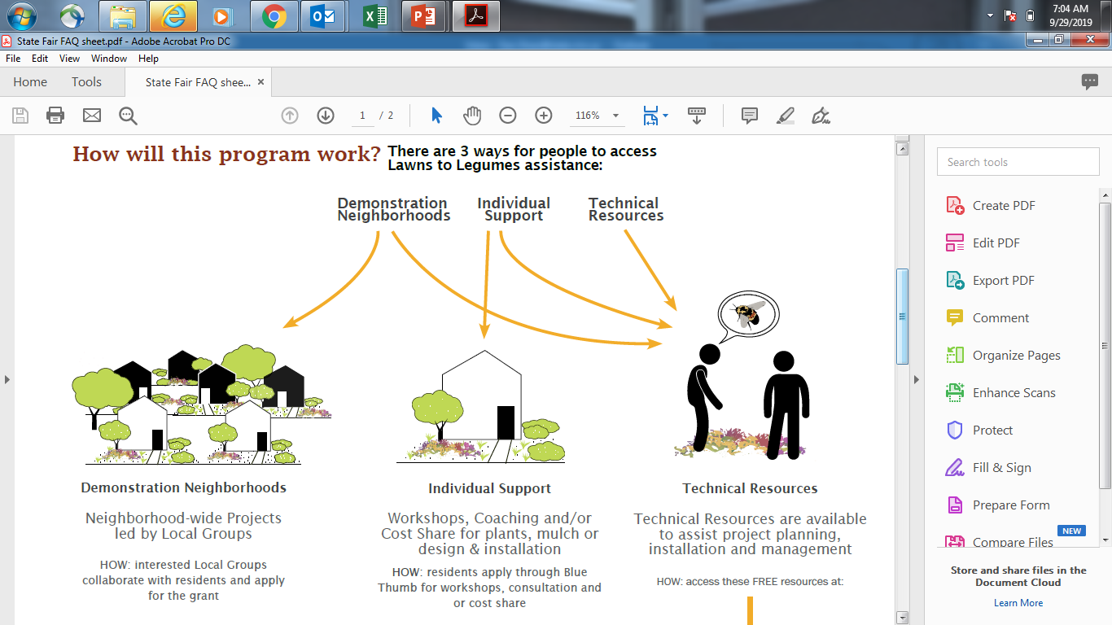

Program Components:
1) “Demonstration Neighborhoods” - A competitive request for proposal will be released for local partners work with landowners in neighborhoods to establish high value pollinator habitat. Eligible applicants could include cities, counties, watershed districts, conservation districts, tribes and non-profits. Applicants can involve conservation partnerships and they will provide technical and financial assistance to around 300 landowners to establish successful and resilient plantings that build pollinator pathways and provide high quality habitat for at-risk pollinators. A variety of planting types such as native pocket plantings, pollinator beneficial trees and shrubs, pollinator lawns and pollinator meadows will be encouraged within the neighborhoods.
2) Individual Landowner Support – This component of the program will be coordinated by the Blue Thumb Partnership and will include cost-share funding, coaching and workshops. Cost-share and/or guidance will be provided to 700-1200 landowners as well as project recognition through signage. The goals of this component are to establish successful projects that will provide high value to at-risk pollinators while increasing neighborhood support for the establishment of pollinator habitat. As part of this component, a new Residential Pollinator Guide and planting templates have been posted to the program website.
3) A Public Outreach Campaign - Coordinated by BWSR, the Blue Thumb Partnership, The Minneapolis College of Art and Design and other conservation, local government and education partners, a public outreach campaign will be conducted to provide impactful outreach to sustain and increase momentum for the adoption of residential pollinator habitat and alternative groundcovers across Minnesota. This component of the program will encourage and assist landowners who want to conduct projects on their own through outreach, technical information and guidance (involving over 5,000 landowners). BWSR, Blue Thumb and the Minneapolis College of Art and Design will be working on social networking messages that can be shared across organizations.
Collaboration Opportunities
- Demonstration Neighborhoods
Partners including conservation districts, watershed districts, cities, counties, tribes and nongovernmental organizations will be eligible to apply for funding for demonstration neighborhoods through a competitive RFP. The definition of a “neighborhood” is to be determined by local partners (it could be one to several blocks or even a grouping of farmsteads). The neighborhood should be in an important pollinator corridor/pathway/sweet spot. The funding is for residential projects but matching projects on adjoining public land (parks, schools, community gardens, trails) is encouraged. There is significant potential for collaboration between partners on these applications. Not all landowners need to be identified as part of the response to the RFP. Grant funds can help cover prioritization, outreach and landowner coordination.
- Sponsorship of Workshops
20+ landowner workshops and 4+ train the trainer workshops are being planned for the program. The landowner workshops will involve a presentation and then time for designers, Master Gardeners and Master Water Stewards to work with landowners (to help them plan their projects). The workshops are often co-sponsored by local governments/organizations. The schedule for the train the trainer workshops can be found at bluethumb.org. Please contact John Bly at john@metroblooms.org if you are interested in sponsoring a workshop.

- Workshop Design Assistance
Master Gardeners and Master Water Stewards are needed to provide design assistance to landowners during workshops. Please contact John Bly at john@metroblooms.org if you are interested in providing design assistance.
- Sharing Workshop Content
Workshop presentations can also be shared with other organizations, please contact dan.shaw@state.mn.us if you are interested in collaborating on workshops.
- Matching Funds/Project Assistance
Cost-share funding will be going out to landowners for the individual support portion of this program starting in the spring of 2020. We are asking landowners if we can share their names with other conservation organizations to potentially match funding with other programs or help fund projects that do not receive Lawns to Legumes funding. Please contact us if you are interested in finding out who is funded in your project areas.
- Coaching Calls/Sharing Expertise
The Lawns to Legumes program will only be successful through shared technical knowledge about the establishment and management of pollinator habitat. We will be conducting 4+ train the trainer workshops (including a webinar) to share technical information with conservation professionals about habitat establishment and management. Any help that partners can provide to landowners who are receiving funding or requesting technical assistance is appreciated!
- On-site Consultations
In addition to assisting with coaching calls, assistance is also needed with conducting on-site consultations. This may be an opportunity for Master Water Stewards to receive volunteer hours but there is also some funding available for Conservation District staff or others to conduct these visits, particularly in parts of the state where we don’t have other staff that can assist. If you are interested in conducting on-site consultations, please contact john Bly at john@metroblooms.org.
- Sharing Social Media
Blue Thumb and BWSR are collaborating with classes at the Minneapolis College of Art and Design to develop social media that will be shared through partner communications to enhance the public outreach campaign. Social media on topics such as pollinators, native plants, planting methods and management will also be shared over the three years of the program.

- Sharing Logos and Marketing
In addition to the sharing of social media, the logo and marketing materials for the program can also be shared according to program guidelines. Please contact BWSR’s Communications Coordinator, Mary Juhl (Mary.Juhl@state.mn.us) if you are interested in using the logo or other marketing materials.
- Highlighting Local Conservation Efforts
As social media and marketing for the program is shared it is also a great opportunity to highlight local conservation efforts that have related goals. It is a good opportunity to link interest in pollinator habitat with other conservation efforts that are happening around the state.
- Working with City Ordinances
As part of the Lawns to Legumes program a sample landscaping permit has been developed that cities can use along with their city ordinances that relate to lawns and weeds. We encourage partners to collaborate with city staff to discuss local ordinances and whether the use of this sample permit or revisions to existing landscape ordinances can help accommodate different types of pollinator plantings. Signage will also play an important role in communicating the intent of projects.
- Custom Recognition Signage
Two-thousand Lawns to Legumes signs are being printed in the fall of 2019 that will be provided to landowners who receive funding but we would also like to send signs out to as many landowners as possible who are installing projects on their own. If cities or other partners are interested in cost-sharing on the development and distribution of custom Lawns to Legumes signs specific to a geographic areas please contact Dan Shaw at dan.shaw@state.mn.us
- Shared Technical Resources
A wide range of shared technical resources have been developed and are on BWSR’s Pollinator Toolbox as part of the Residential Habitat page. This includes a Residential Habitat Guide developed by BWSR, Blue Thumb and Xerces Society. These materials can be used as needed by conservation partners.
- Assisting Residents Applying for Support
Landowners will be directed from the Lawns to Legumes website to the Blue Thumb website www.bluethumb.org for landowner workshop registration and cost share applications. Landowners can also be directed to bluethumb.org for technical resources.
- What’s Working Information
BWSR has a What’s Working for Conservation website that includes information about strategies that have been successful for projects. More information is needed from conservation partners and landowners about what is being successful for pollinator plantings as part of this program and other efforts. Please send information and images to dan.shaw@state.mn.us.

Summary of Lawns to Legumes Partnership Opportunities
 | Demonstration Neighborhoods | Sponsorship of Workshops | Sharing Workshop Content | Workshop Design Assistance | Matching Funding/Project Assistance | Coaching Calls/Sharing Expertise | On-site Consultation | Sharing Social Media | Sharing Logos and Marketing | Highlighting Local Conservation Efforts | Assisting with City Ordinances | Custom Recognition Signage | Shared Technical Resources | Assisting Residents Applying for Support | Sharing Whats Working Information
Conservation Districts | X | X | X |  | X | X | X | X | X | X | X | X | X | X | X
Watershed Districts | X | X | X |  | X | X | X | X | X | X | X | X | X | X | X
University of MN Extension |  |  | X |  |  | X | X | X | X | X | X |  | X | X | X
Master Gardeners |  |  |  | X |  | X |  | X | X |  | X |  | X | X | X
Master Water Stewards |  |  |  | X |  | X | X | X | X |  | X |  | X | X | X
Master Naturalists |  |  |  | X |  | X | X | X | X |  | X |  | X | X | X
Environmental Non-Profits | X |  | X |  | X | X | X | X | X | X | X |  | X | X | X
Consultants/  Designers |  |  |  |  |  | X | X | X |  |  | X |  | X | X | X
Tribes | X |  | X |  | X | X | X | X | X | X | X | X | X | X | X
Cities | X |  | X | X | X | X | X | X | X | X | X | X | X | X | X
Counties | X |  | X | X | X | X | X | X | X | X | X | X | X | X | X

